**Computer Applications Project**

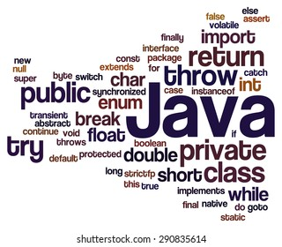

**Name: Allen Thomas M**

**Class:** **10th** **Section:** **C**

**Register Number:**

**Date of Submission:**

**Year:** **2025-2026**



Table Of Contents

Project Preview 4

Program-1 6

**Program Name:** Sum_and_Product 6

Program-2 8

**Program Name:** Area_of_Circle 8

Program-3 10

**Program Name:** Sum_of_First_and_Last_Digit 10

Program-4 12

**Program Name:** Square_and_Cube 12

Program-5 14

**Program Name:** Time 14

Program-6 16

**Program Name:** Even_or_Odd 16

Program-7 18

**Program Name:** Positive_or_Negative 18

Program-8 20

**Program Name:** Leap_Year 20

Program-9 22

**Program Name:** Largest_of_two_Numbers 22

Program-10 24

**Program Name:** Buzz_Number 24

Program-11 26

**Program Name:** Largest_of_three_Numbers 26

Program-12 28

**Program Name:** Triangles 28

Program-13 30

**Program Name:** Kilometres 30

Program-14 33

**Program Name:** Electricity 33

Program-15 37

**Program Name:** Salary 37

Program-16 40

**Program Name:** Basic_Pay 40

Program-17 43

**Program Name:** DAYS 43

Program-18 45

**Program Name:** Interest 45

Program-19 48

**Program Name:** Grades 48

Program-20 51

**Program Name:** Electronics_World 51

Program-21 57

**Program Name:** Switch_Case_1 57

Program-22 61

**Program Name:** Switch_Case_2 61

Program-23 67

**Program Name:** Switch_Case_3 67

Program-24 77

**Program Name:** Switch_Case_4 77

Program-25 84

**Program Name:** Alphabets 84

Program-26 87

**Program Name:** Ushwa_Number 87

Program-27 90

**Program Name:** Days_Months 90

Program-28 93

**Program Name:** Series1 93

Program-29 98

**Program Name:** Magic_Number 98

Program-30 101

**Program Name:** Fibonacci 101

Program-31 103

**Program Name:** Tribonacci 103

Program-32 105

**Program Name:** Sunny_Number 105

Program-33 107

**Program Name:** series 107

Project Acknowledgement 115

# **Project Preview**

This project collates all the Java Programs that were done during 9th Grade. The Programs in the project leverages the Scanner class to make it user interactive. The project covers conditional constructs (if, else if, else), looping constructs (while and for), as well as menu-driven programs utilizing switch-case control structures.

The Project was run using BlueJ. The codebase is shared at Github. The location for the same is provided below.

<https://github.com/allenthomasmuttikal/Java_Project>



**JAVA Programs**

# **Program-1**

## **Program Name:** Sum_and_Product

### **Problem Statement:** Develop a Java program that prompts the user to input two integers. The program should then calculate and display both the sum and the product of these numbers.

### **Java Code:**

import java.util.Scanner;

/**

* This program calculates and displays the sum and product of the entered 2 numbers

*

* @author (Allen Thomas.M)

* @author email (allenthomasmuttikal@gmail.com)

* @author git(https://github.com/allenthomasmuttikal/Java_Project)

* @version (v1.0)

*/

public class Sum_and_Product

{

public static void main(String args[])

{

Scanner ob = new Scanner(System.in);

System.out.println("Enter 2 numbers");

int a = ob.nextInt();

int b = ob.nextInt();

int sum = a + b;

int prod = a * b;

System.out.println("Output:");

System.out.println("The sum of the 2 numbers is "+sum);

System.out.println("The product of the 2 numbers is "+prod);

}

}

### **Variables Used:**

|  |  |  |
| --- | --- | --- |
| **Variable Name** | **Variable Datatype** | **Variable Description** |
| **ob** | Scanner | Object to read user input from the console. |
| **a** | int | First integer input provided by the user. |
| **b** | int | Second integer input provided by the user. |
| **sum** | int | Stores the sum of the two integers a and b. |
| **prod** | int | Stores the product of the two integers a and b. |

### **Output:**

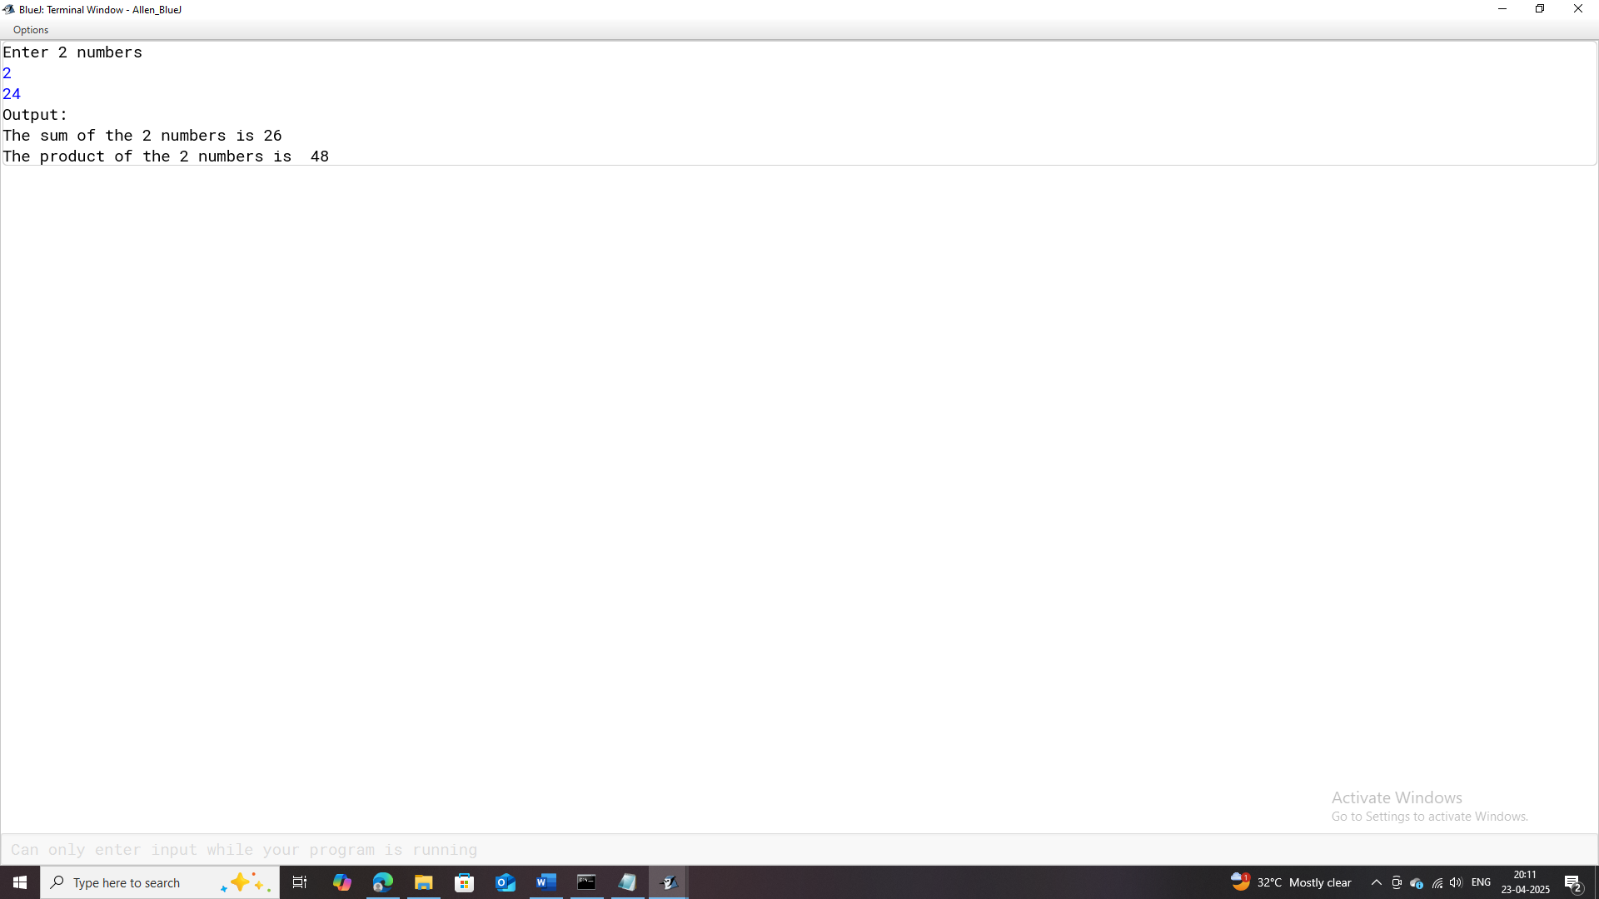

# **Program-2**

## **Program Name:** Area_of_Circle

### **Problem Statement:** Design a Java program that calculates and displays the area of a circle based on a user-provided radius.

### **Java Code:**

import java.util.Scanner;

/**

* This program calculates and displays the area of a circle with the entered radius

*

* @author (Allen Thomas.M)

* @author email (allenthomasmuttikal@gmail.com)

* @author git(https://github.com/allenthomasmuttikal/Java_Project)

* @version (v1.0)

*/

public class Area_of_Circle

{

public static void main(String args[])

{

Scanner ob = new Scanner(System.in);

float pi = 3.14f;

float radius = 0.0f,area = 0.0f;

System.out.println("Enter the radius");

radius = ob.nextFloat();

area = pi * radius * radius;

System.out.println("Output:");

System.out.println("The area of the circle with radius "+radius+" is : "+area);

}

}

### **Variables Used:**

|  |  |  |
| --- | --- | --- |
| **Variable Name** | **Variable Datatype** | **Variable Description** |
| **ob** | Scanner | Object for reading user input from the console. |
| **pi** | float | Represents the constant value of pi (3.14). |
| **radius** | float | Stores the user-entered radius of the circle. |
| **area** | float | Stores the calculated area of the circle. |

### **Output:**

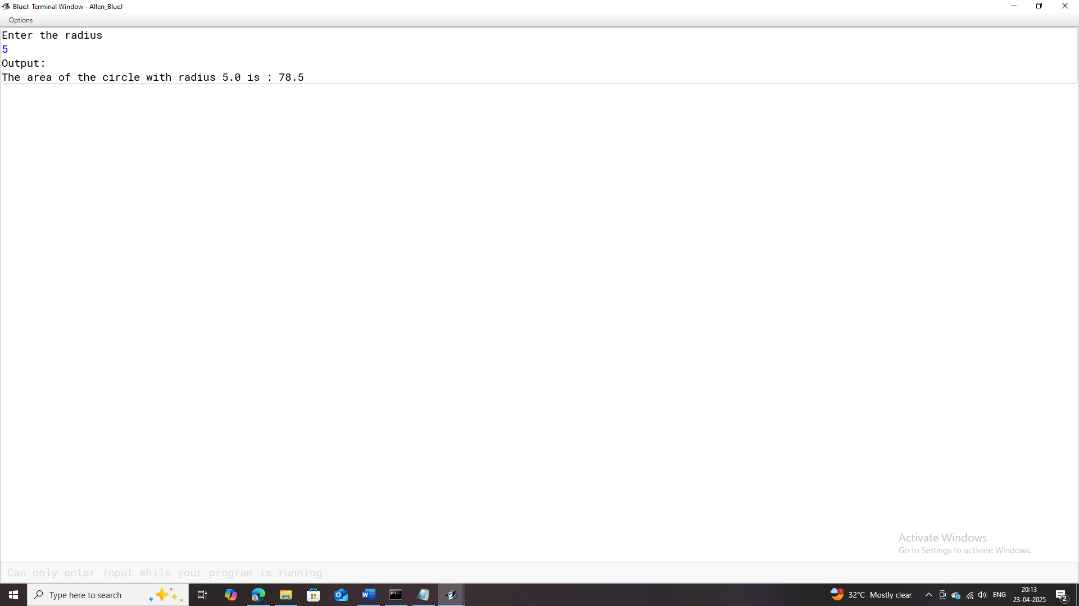

# **Program-3**

## **Program Name:** Sum_of_First_and_Last_Digit

### **Problem Statement:** Create a Java program that calculates and displays the sum of the first and last digits of a three-digit number.

### **Java Code:**

import java.util.Scanner;

/**

* This program calculates and displays the sum of the first and last digit of the entered 3 digit number

*

* @author (Allen Thomas.M)

* @author email (allenthomasmuttikal@gmail.com)

* @author git(https://github.com/allenthomasmuttikal/Java_Project)

* @version (v1.0)

*/

public class Sum_of_First_and_Last_Digit

{

public static void main(String args[])

{

Scanner ob = new Scanner(System.in);

System.out.println("Enter the 3 digit number");

int num = ob.nextInt();

int first = num / 100,last = num % 10,sum = first + last;

System.out.println("Output:");

System.out.println("The first digit is : "+first);

System.out.println("The last digit is : "+last);

System.out.println("The sum of the first and last digit is : "+sum);

}

}

### **Variables Used:**

|  |  |  |
| --- | --- | --- |
| **Variable Name** | **Variable Datatype** | **Variable Description** |
| ob | Scanner | Object for reading user input from the console. |
| num | int | Stores the 3-digit number input provided by the user. |
| first | int | Extracts and stores the first digit of the number num. |
| last | int | Extracts and stores the last digit of the number num. |
| sum | int | Stores the sum of the first and last digits of num. |

### **Output:**

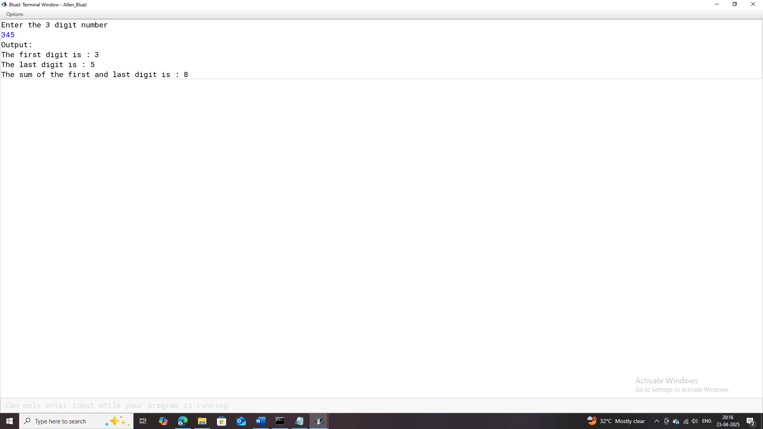

# **Program-4**

## **Program Name:** Square_and_Cube

### **Problem Statement:** Develop a Java program that prompts the user to enter an integer. The program should then calculate and display both the square and the cube of the entered number.

### **Java Code:**

import java.util.Scanner;

/**

* This program calculates and displays the sqaure and cube of the entered number

*

* @author (Allen Thomas.M)

* @author email (allenthomasmuttikal@gmail.com)

* @author git(https://github.com/allenthomasmuttikal/Java_Project)

* @version (v1.0)

*/

public class Square_and_Cube

{

public static void main(String args[])

{

Scanner ob = new Scanner(System.in);

System.out.println("Enter the number");

int num = ob.nextInt();

int square = num * num,cube = num * num * num;

System.out.println("Output:");

System.out.println("The Square of "+num+" is : "+square);

System.out.println("The cube of "+num+" is : "+cube);

}

}

### **Variables Used:**

|  |  |  |  |
| --- | --- | --- | --- |
| **Variable Name** | **Variable Datatype** | | **Variable Description** |
| **Ob** | Scanner | Object to read user input from the console. | |
| **Num** | int | Stores the number input by the user. | |
| **Square** | int | Stores the square of the user-entered number num. | |
| **Cube** | int | Stores the cube of the user-entered number num. | |

### **Output:**

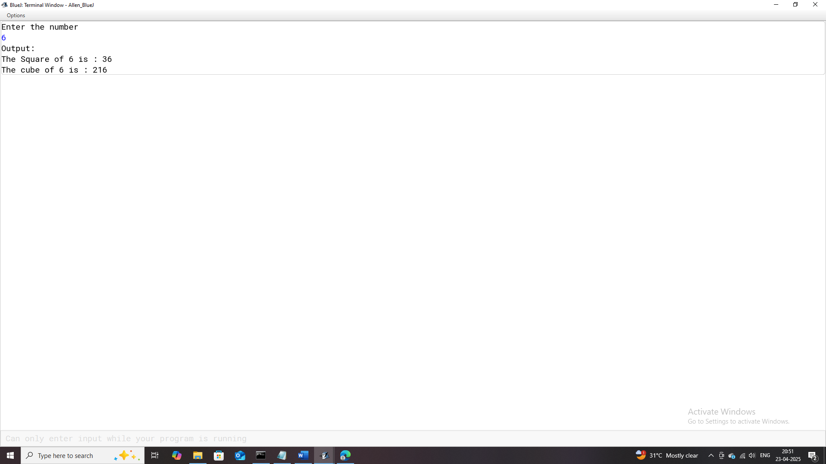

# **Program-5**

## **Program Name:** Time

### **Problem Statement:** Design a Java program that converts a time duration given in seconds into its equivalent representation in hours, minutes, and seconds.

### **Java Code:**

import java.util.Scanner;

/**

* This program calculates and displays the time in hours, minutes and seconds, when the time is entered in seconds

*

* @author (Allen Thomas.M)

* @author email (allenthomasmuttikal@gmail.com)

* @author git(https://github.com/allenthomasmuttikal/Java_Project)

* @version (v1.0)

*/

public class Time

{

public static void main(String args[])

{

/*

* 1 min=60sec

1 hr=60*60sec=3600secs

18005secs=18005/3600=hrs

18065secs=18065/3600=5hrs

18065secs=(18065%3600)/60=1min

18065secs=(18065%3600)%60=5secs

*/

Scanner ob = new Scanner(System.in);

System.out.println("Enter the time in seconds");

int sec = ob.nextInt();

int hours = sec / 3600;

int minutes = (sec % 3600) / 60;

int seconds = (sec % 3600) % 60;

System.out.println("Output:");

System.out.println(sec+" seconds is "+hours+" hours "+minutes+" minutes and "+seconds+" seconds" );

}

}

### **Variables Used:**

|  |  |  |
| --- | --- | --- |
| **Variable Name** | **Variable Datatype** | **Variable Description** |
| **ob** | Scanner | Object for reading user input from the console. |
| **sec** | int | Stores the total number of seconds input by the user. |
| **hours** | int | Stores the calculated hours extracted from sec. |
| **minutes** | int | Stores the calculated minutes extracted from sec. |
| **seconds** | int | Stores the remaining seconds after hours and minutes are calculated. |

### **Output:**

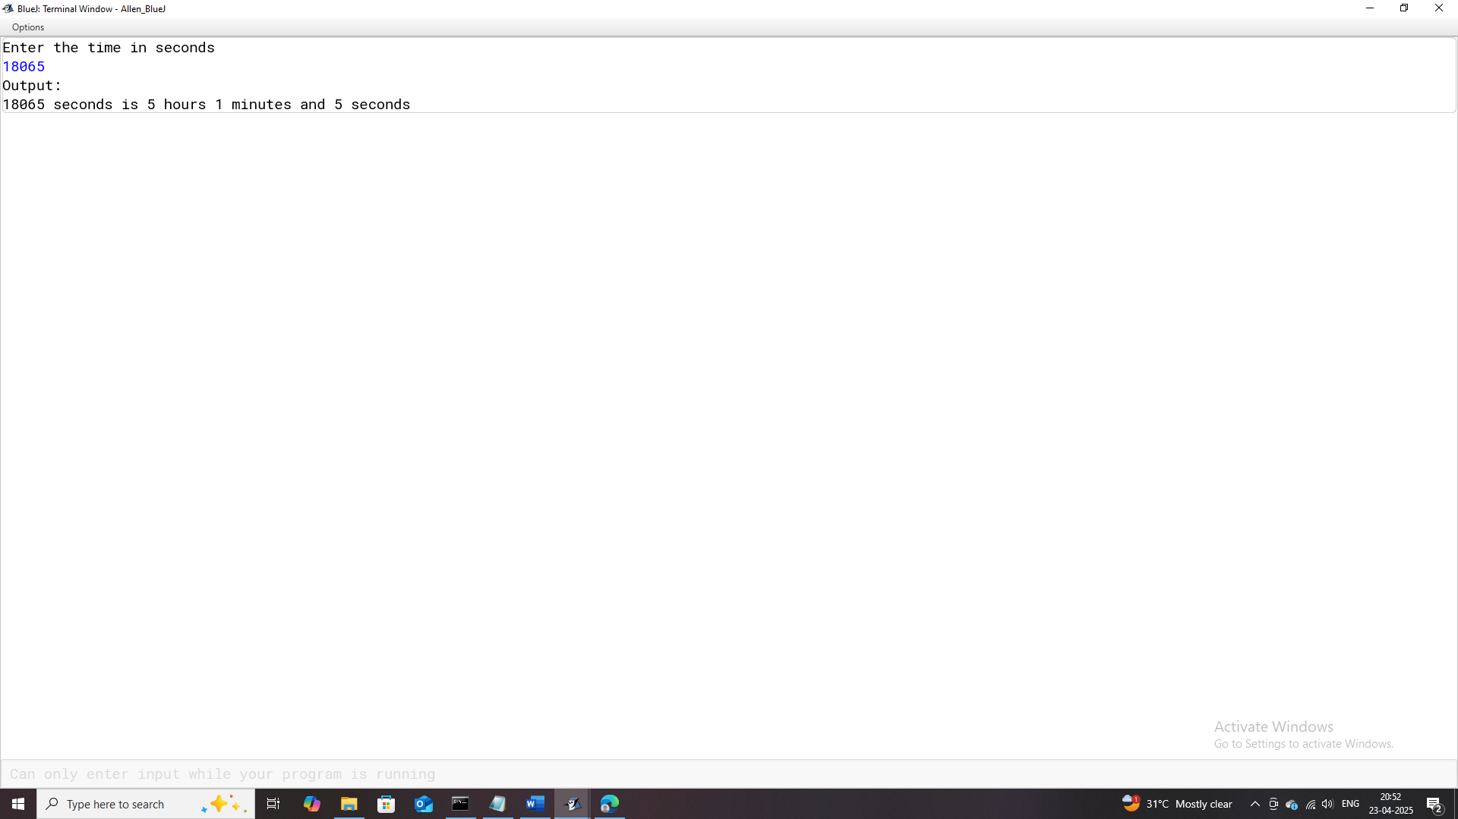

# **Program-6**

## **Program Name:** Even_or_Odd

### **Problem Statement:** Create a Java program that determines whether a given integer is even or odd.

### **Java Code:**

import java.util.Scanner;

/**

* This program checks and displays if the entered number is an even or odd number

*

* @author (Allen Thomas.M)

* @author email (allenthomasmuttikal@gmail.com)

* @author git(https://github.com/allenthomasmuttikal/Java_Project)

* @version (v1.0)

*/

public class Even_or_Odd

{

public static void main(String args[])

{

Scanner ob = new Scanner(System.in);

System.out.println("Enter the number");

int num = ob.nextInt();

System.out.println("Output:");

if(num % 2 == 0)

System.out.println(num+" is an Even Number");

else

System.out.println(num+" is an Odd Number");

}

}

### **Variables Used:**

|  |  |  |  |  |  |  |  |  |  |
| --- | --- | --- | --- | --- | --- | --- | --- | --- | --- |
| |  |  |  | | --- | --- | --- | | **Variable Name** | **Variable Datatype** | **Variable Description** | | **ob** | Scanner | Object to read user input from the console. | | **num** | int | Stores the number input provided by the user. | |

### **Output:**

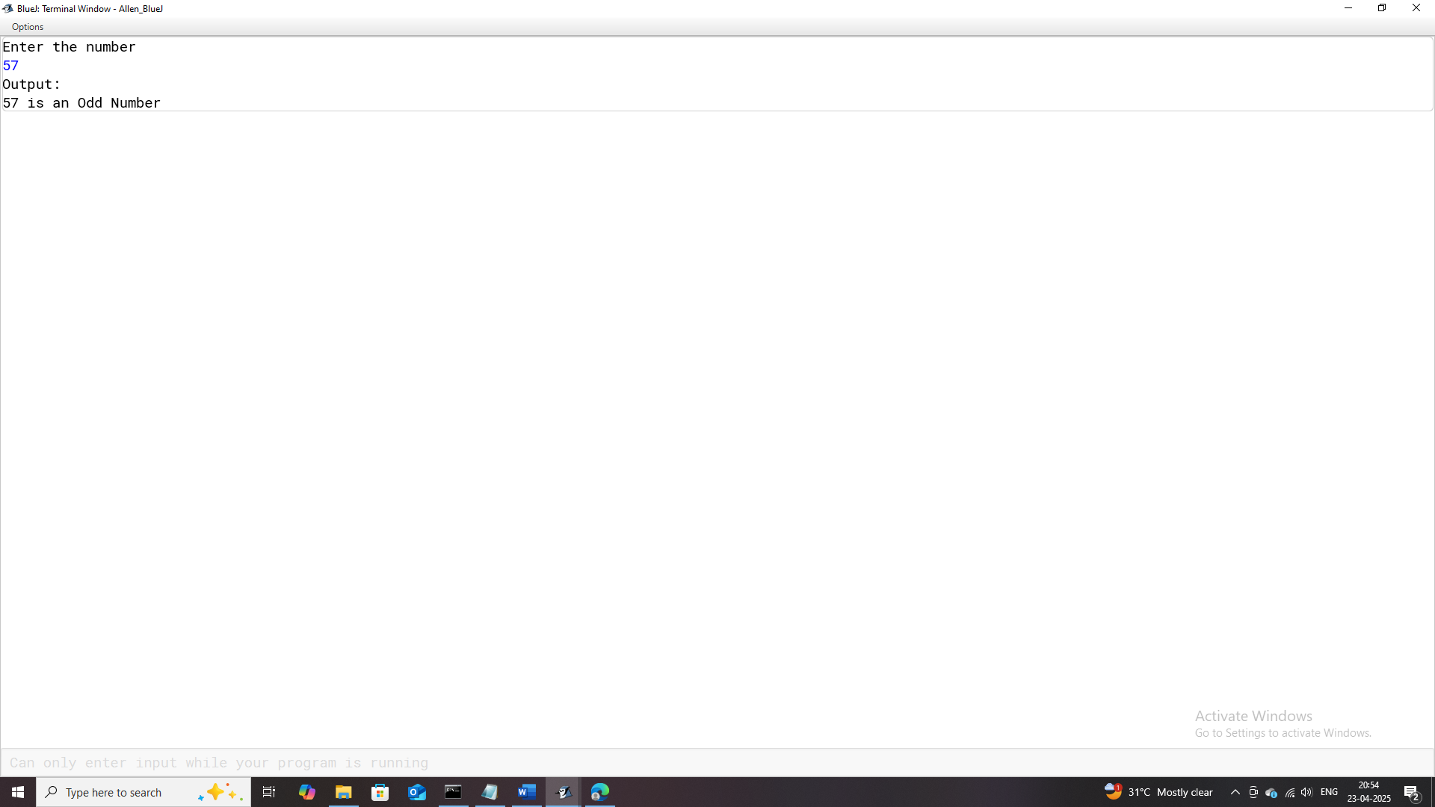

# **Program-7**

## **Program Name:** Positive_or_Negative

### **Problem Statement:** Design a Java program that determines whether a given integer is positive, negative, or zero.

### **Java Code:**

import java.util.Scanner;

/**

* This program checks and displays if the entered number is a Positive or Negative Number.

*

* @author (Allen Thomas.M)

* @author email (allenthomasmuttikal@gmail.com)

* @author git(https://github.com/allenthomasmuttikal/Java_Project)

* @version (v1.0)

*/

public class Positive_or_Negative

{

public static void main(String args[])

{

Scanner ob = new Scanner(System.in);

System.out.println("Enter a number");

int num = ob.nextInt();

System.out.println("Output:");

if(num > 0)

System.out.println(num+" is a Positive Number");

else if(num < 0)

System.out.println(num+" is a Negative Number");

else

System.out.println(num+" is zero");

}

}

### **Variables Used:**

|  |  |  |
| --- | --- | --- |
| **Variable Name** | **Variable Datatype** | **Variable Description** |
| **ob** | Scanner | Object to read user input from the console. |
| **num** | int | Stores the number input provided by the user. |

### **Output:**

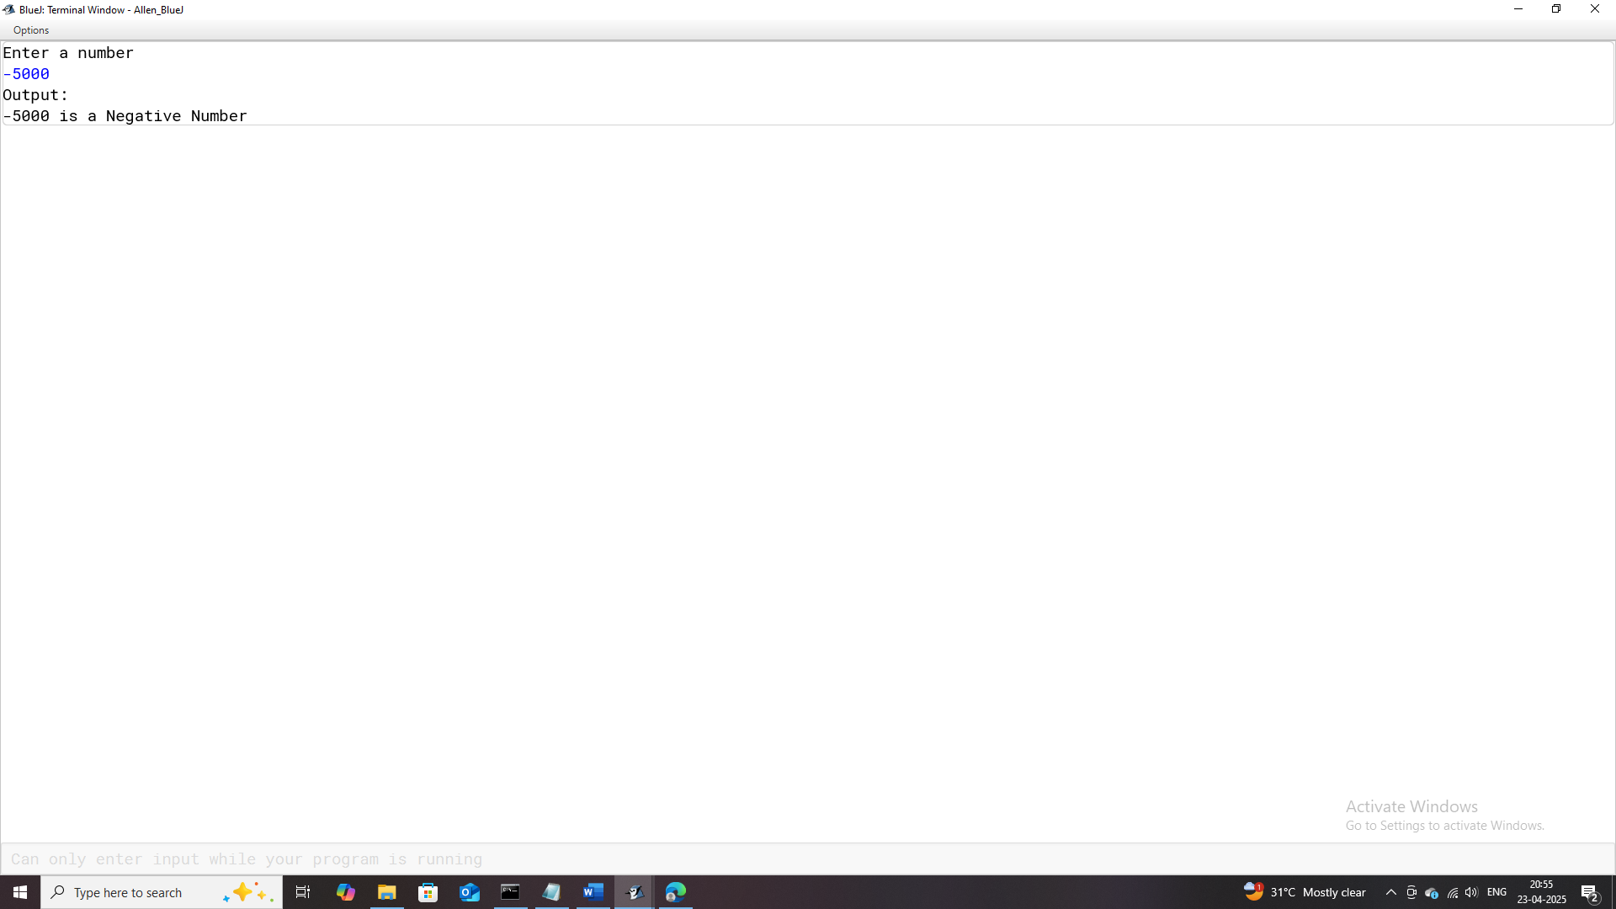

# **Program-8**

## **Program Name:** Leap_Year

### **Problem Statement:** Develop a Java program that determines whether a given year is a leap year or not.

### **Java Code:**

import java.util.Scanner;

/**

* This program checks and displays if the entered year is a Leap Year.

*

* @author (Allen Thomas.M)

* @author email (allenthomasmuttikal@gmail.com)

* @author git(https://github.com/allenthomasmuttikal/Java_Project)

* @version (v1.0)

*/

public class Leap_Year

{

public static void main(String args[])

{

Scanner ob = new Scanner(System.in);

System.out.println("Enter the year");

int year = ob.nextInt();

System.out.println("Output:");

if(year % 4 == 0 && year % 100 != 0) // Leap Year is divisible by 4 and not by 100(not a century year).

System.out.println(year+" is a Leap Year");

else if(year % 100 == 0 && year % 400 == 0) // Leap year is divisible by both 100 and 400.

System.out.println(year+" is a Leap Year");

else

System.out.println(year+" is not a Leap Year");

}

}

### **Variables Used:**

|  |  |  |
| --- | --- | --- |
| **Variable Name** | **Variable Datatype** | **Variable Description** |
| ob | Scanner | Object to read user input from the console. |
| year | int | Stores the year entered by the user to check if it's a |

### **Output:**

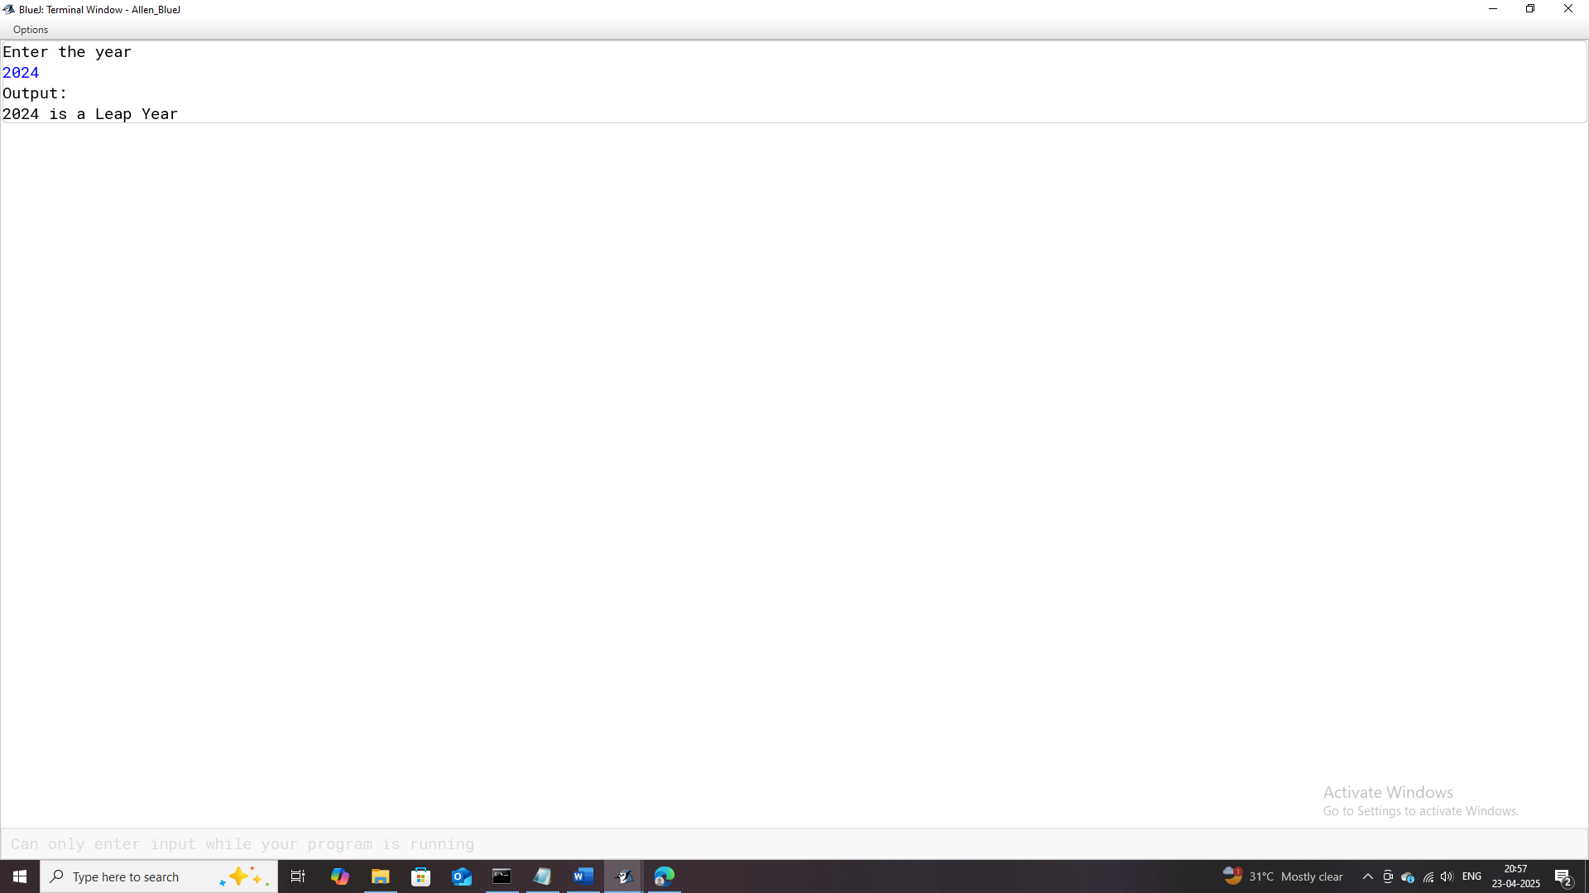

# **Program-9**

## **Program Name:** Largest_of_two_Numbers

### **Problem Statement:** Develop a Java program that compares two integer values inputted by the user and identifies the larger number.

### **Java Code:**

import java.util.Scanner;

/**

* This program compares and displays which among the entered 2 numbers is greater

*

* @author (Allen Thomas.M)

* @author email (allenthomasmuttikal@gmail.com)

* @author git(https://github.com/allenthomasmuttikal/Java_Project)

* @version (v1.0)

*/

public class Largest_of_two_Numbers

{

public static void main(String args[])

{

Scanner ob = new Scanner(System.in);

System.out.println("Enter any 2 numbers");

int a = ob.nextInt();

int b = ob.nextInt();

System.out.println("Output:");

if(a > b)

System.out.println(a+" is greater than "+b);

else if(b > a)

System.out.println(b+" is greater than "+a);

else

System.out.println(" Both the numbers are equal");

}

}

### **Variables Used:**

|  |  |  |
| --- | --- | --- |
| **Variable Name** | **Variable Datatype** | **Variable Description** |
| **ob** | Scanner | Object to read user input from the console. |
| **a** | int | Stores the first number input provided by the user. |
| **b** | int | Stores the second number input provided by the user. |

### **Output:**

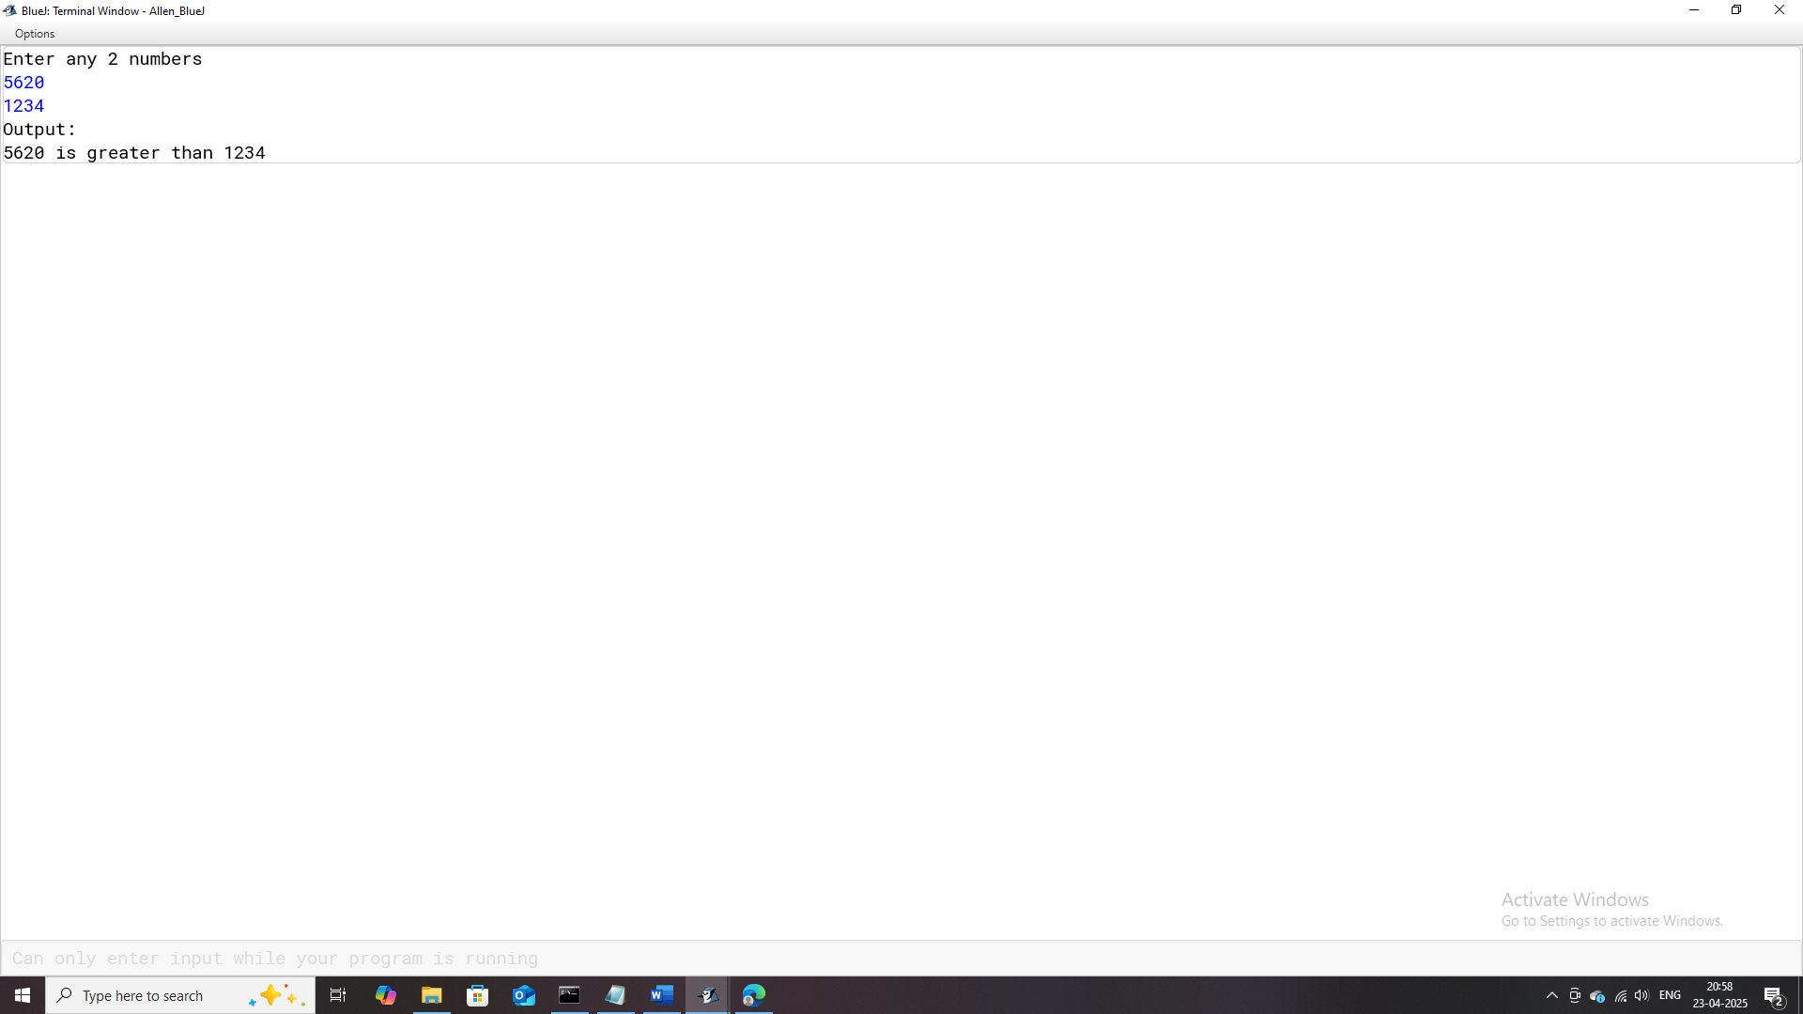

# **Program-10**

## **Program Name:** Buzz_Number

### **Problem Statement:** Design a Java program to determine whether a given integer is a "Buzz Number." In mathematical terms, a "Buzz Number" is a number that either ends with the digit 7 or is divisible by 7.

### **Java Code:**

import java.util.Scanner;

/**

* This program checks and displays if the entered number is a Buzz Number

*

* NOTE:In a mathematical context, a "buzz number" is a number that either

* ends in the digit 7 or is divisible by 7. A number that satisfies either

* of these conditions is considered a buzz number.

*

* @author (Allen Thomas.M)

* @author email (allenthomasmuttikal@gmail.com)

* @author git(https://github.com/allenthomasmuttikal/Java_Project)

* @version (v1.0)

*/

public class Buzz_Number

{

public static void main(String args[])

{

Scanner ob = new Scanner(System.in);

System.out.println("Enter a number");

int num = ob.nextInt();

System.out.println("Output:");

if(num % 7 == 0 || num % 10 == 7)

System.out.println(num+" is a Buzz Number");

else

System.out.println(num+" is not a Buzz Number");

}

}

### **Variables Used:**

|  |  |  |
| --- | --- | --- |
| **Variable Name** | **Variable Datatype** | **Variable Description** |
| **ob** | Scanner | Object used to read user input from the console. |
| **num** | int | Stores the number input by the user to check if it's a Buzz Number. |

### **Output:**

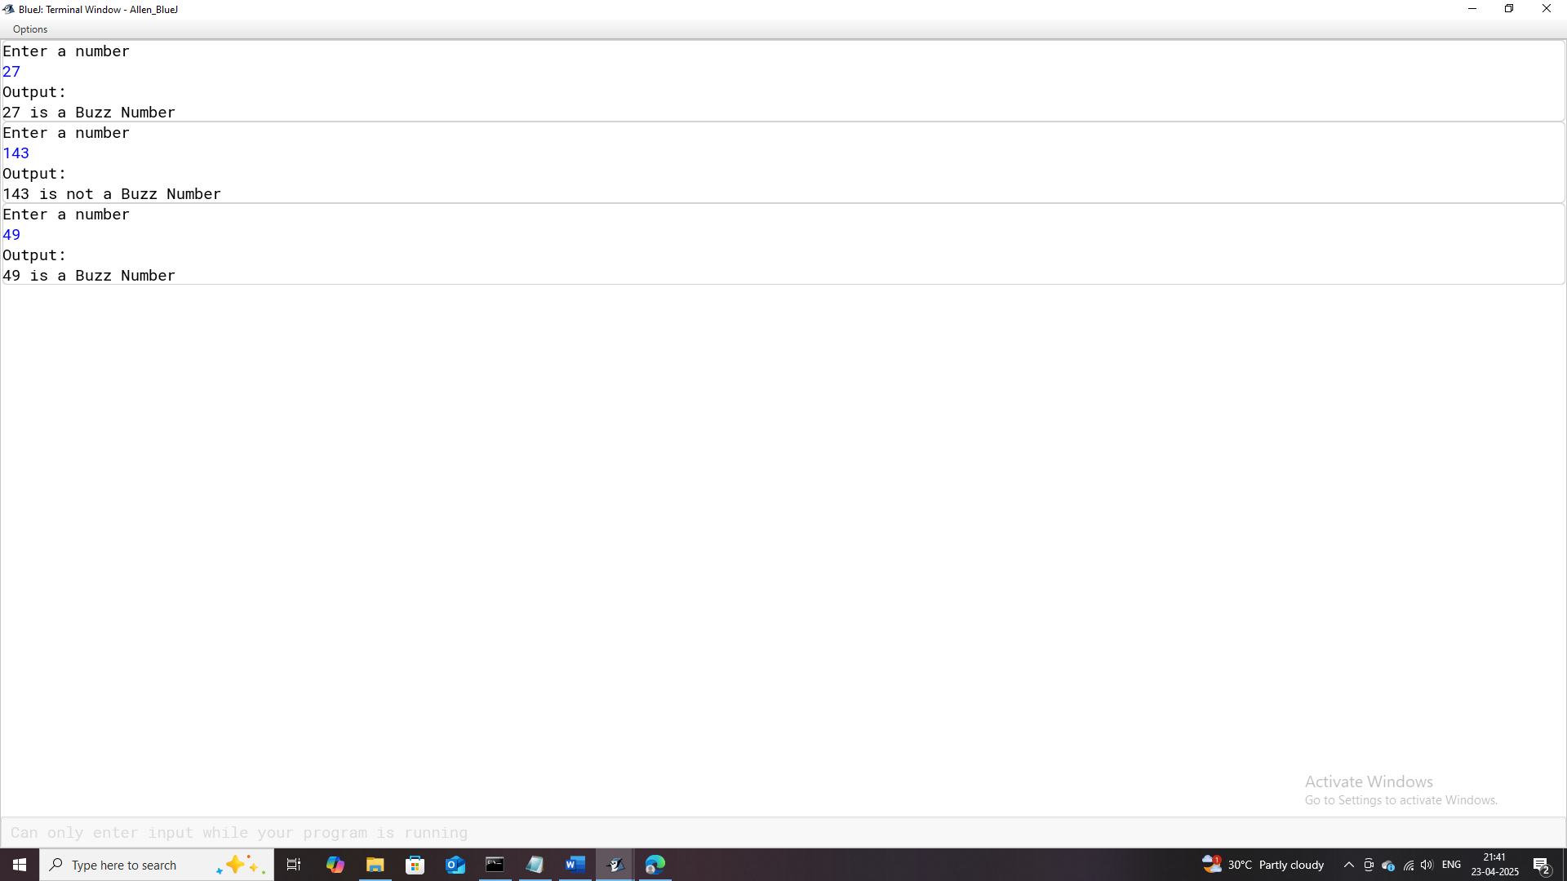

# **Program-11**

## **Program Name:** Largest_of_three_Numbers

### **Problem Statement:** Create a Java program that identifies the greatest of three inputted integers.

### **Java Code:**

import java.util.Scanner;

/**

* This program checks and displays the Greatest Number of the entered 3 numbers

*

* @author (Allen Thomas.M)

* @author email (allenthomasmuttikal@gmail.com)

* @author git(https://github.com/allenthomasmuttikal/Java_Project)

* @version (v1.0)

*/

public class Largest_of_three_Numbers

{

public static void main(String args[])

{

Scanner ob = new Scanner(System.in);

System.out.println("Enter any 3 numbers");

int a = ob.nextInt();

int b = ob.nextInt();

int c = ob.nextInt();

System.out.println("Output:");

if(a > b && a > c)

System.out.println(a+" is Greatest");

else if(b > a && b > c)

System.out.println(b+" is Greatest");

else if(c > a && c > b)

System.out.println(c+" is Greatest");

else if(a == b && b == c)

System.out.println(" All 3 numbers are equal");

}

}

### **Variables Used:**

|  |  |  |
| --- | --- | --- |
| **Variable Name** | **Variable Datatype** | **Variable Description** |
| **ob** | Scanner | Object used to read user input from the console. |
| **a** | int | Stores the first number input by the user. |
| **b** | int | Stores the second number input by the user. |
| **c** | int | Stores the third number input by the user. |

### **Output:**

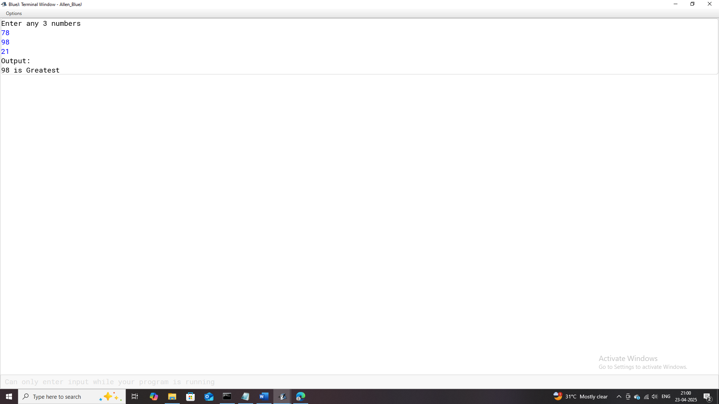

# **Program-12**

## **Program Name:** Triangles

### **Problem Statement:** Develop a Java program that determines whether a triangle can be formed using three user-provided side lengths. If the sides satisfy the triangle inequality theorem, classify the triangle as Equilateral, Isosceles, or Scalene based on its side lengths.

### **Java Code:**

import java.util.Scanner;

/**

* This program calculates if a triangle is possible from the entered dimension. In addition it classifies the type of triangle.

*

* @author (Allen Thomas.M)

* @author email (allenthomasmuttikal@gmail.com)

* @author git(https://github.com/allenthomasmuttikal/Java_Project)

* @version (v1.0)

*/

public class Triangles

{

public static void main(String args[])

{

Scanner ob = new Scanner(System.in);

System.out.println("Enter dimensions of 3 sides of a triangle");

int a = ob.nextInt();

int b = ob.nextInt();

int c = ob.nextInt();

System.out.println("Output:");

if(a+b>c && b+c>a && a+c>b)

{

System.out.println("Triangle is Possible");

if(a == b && b == c)

System.out.println("It is an Equilateral Triangle");

else if(a == b || b == c || a == c)

System.out.println("It is an Isosceles Triangle");

else

System.out.println("It is a Scalene Triangle");

}

else

System.out.println("Triangle is not Possible");

}

}

### **Variables Used:**

| **Variable Name** | **Variable Datatype** | **Variable Description** |
| --- | --- | --- |
| **ob** | Scanner | Object used to read user input from the console. |
| **a** | int | Stores the length of the first side of the triangle. |
| **b** | int | Stores the length of the second side of the triangle. |
| **c** | int | Stores the length of the third side of the triangle. |

### **Output:**

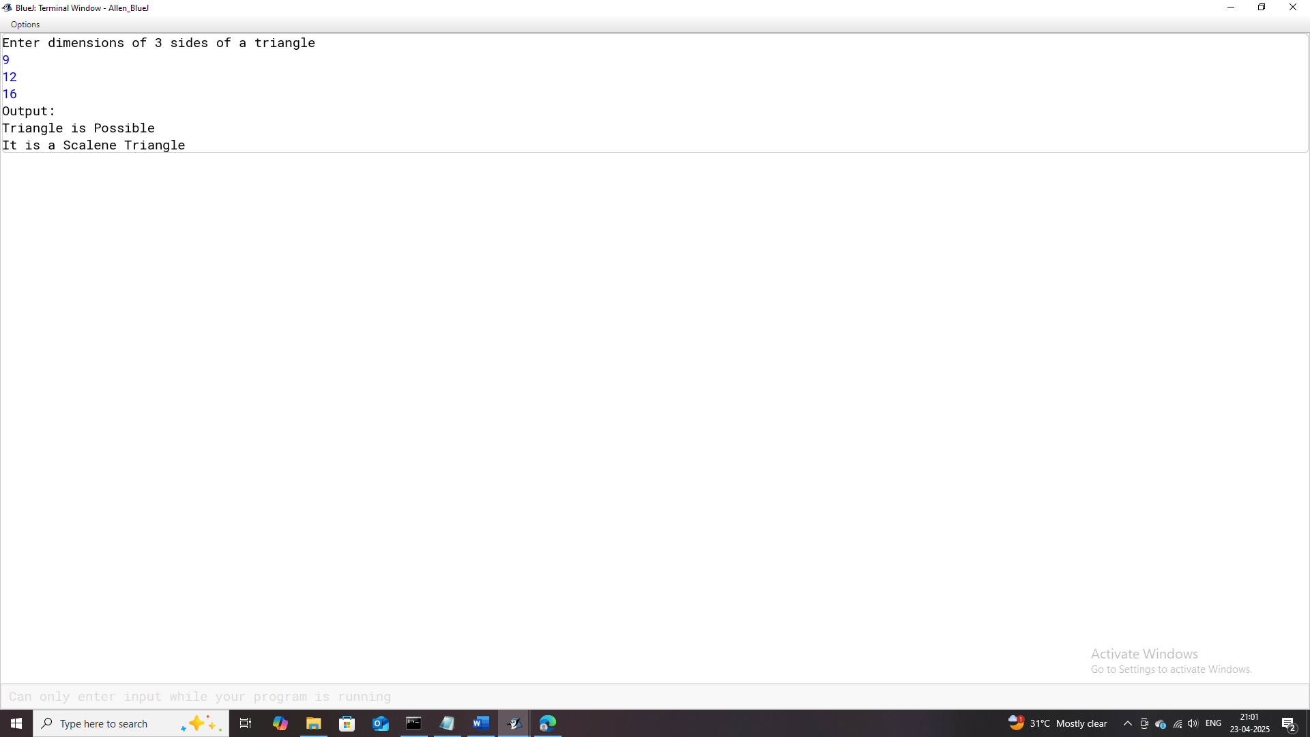

# **Program-13**

## **Program Name:** Kilometres

### **Problem Statement:** Design a Java program to calculate and display the fare for a distance traveled in kilometers, based on predefined fare slabs**.**

* For distances up to 5 kilometers, the fare is ₹50.
* For distances between 6 and 15 kilometers, an additional ₹12 per kilometer is charged.
* For distances between 16 and 35 kilometers, an additional ₹13 per kilometer is charged.
* For distances beyond 35 kilometers, an additional ₹15 per kilometer is charged.

### **Java Code:**

import java.util.Scanner;

/**

* This program calculates the fare depending on the distance travelled based on the slab defined.

* upto 5 km = Rs.50.

* next 10 km = Rs.12/km.

* next 20 km = Rs.13/km.

* further distance=Rs.15/km

*

* @author (Allen Thomas.M)

* @author email (allenthomasmuttikal@gmail.com)

* @author git(https://github.com/allenthomasmuttikal/Java_Project)

* @version (v1.0)

*/

public class Kilometres

{

public static void main(String args[])

{

Scanner ob = new Scanner(System.in);

System.out.println("Enter the distance travelled in kilometeres");

int dist = ob.nextInt();

int fare = 0;

if(dist <= 5)

fare = 50;

else if(dist > 5 && dist <= 15)

fare = 50 + 12 * (dist-5);

else if(dist > 15 && dist <= 35)

fare = 50 + (12*10) + 13 * (dist-15);

else

fare = 50 + (12*10) + (13*20) + 15 * (dist-35);

System.out.println("Output:");

System.out.println("The fare to be paid for "+dist+" kilometers travelled is: \u20B9"+fare);

}

}

### **Variables Used:**

|  |  |  |
| --- | --- | --- |
| **Variable Name** | **Variable Datatype** | **Variable Description** |
| **ob** | Scanner | Object used to read user input from the console. |
| **dist** | int | Stores the total distance travelled in kilometres entered by the user. |
| **fare** | int | Stores the calculated fare based on the distance slab logic. |

### **Output:**

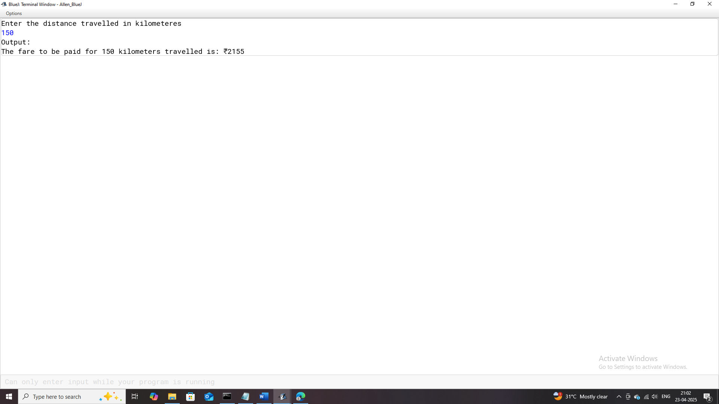

# **Program-14**

## **Program Name:** Electricity

### **Problem Statement:** Develop a Java program to calculate the electricity bill for a consumer based on their energy consumption.

* For the first 100 units, charge ₹1.25 per unit.
* For the next 100 units (101-200), charge ₹1.50 per unit.
* For any units above 200, charge ₹1.80 per unit.

### **Java Code:**

import java.util.Scanner;

/**

* This program calculates and displays the Electricity Bill amount based on the consumption.

* Note: Units Consumed upto 100 is charged 1.25 Rs/Unit

* Units consumed abouve 100 units but below 201 units is charged 1.5 Rs/Unit

* Units above 200 are charged at 1.8 Rs/Unit

*

* @author (Allen Thomas.M)

* @author email (allenthomasmuttikal@gmail.com)

* @author git(https://github.com/allenthomasmuttikal/Java_Project)

* @version (v1.0)

*/

public class Electricity

{

public static void main(String args[])

{

Scanner ob = new Scanner(System.in);

System.out.println("Enter Consumer Name");

String name = ob.nextLine();

System.out.println("Enter Consumer Number");

int num = ob.nextInt();

System.out.println("Enter previous reading");

double pre_read = ob.nextDouble();

System.out.println("Enter current reading");

double cur_read = ob.nextInt();

double units_consumed = cur_read - pre_read;

double bill = 0.0d;

if(units_consumed <= 100.0)

{

bill = 1.25 * units_consumed;

}

else if(units_consumed > 100.0 && units_consumed <= 200)

bill=(1.25*100.0) + 1.50 * (units_consumed-100);

else

bill=(1.25*100.0) + (1.50*100.0) + 1.80 * (units_consumed-200);

System.out.println("Output:");

System.out.println("##########################################################################################");

System.out.println("################################### BILL RECIEPT ########################################");

System.out.println("##########################################################################################");

System.out.println("Consumer Name\tConsumer Number\tUnits Consumed\tBill Amount");

System.out.println(name+"\t"+num+"\t"+units_consumed+"\t"+bill);

System.out.println("##########################################################################################");

}

}

### **Variables Used:**

| **Variable Name** | **Variable Datatype** | **Variable Description** |
| --- | --- | --- |
| **ob** | Scanner | Object used to read user input from the console. |
| **name** | String | Stores the name of the consumer entered by the user. |
| **num** | int | Stores the consumer number entered by the user. |
| **pre_read** | double | Stores the previous electricity meter reading entered by the user. |
| **cur_read** | double | Stores the current electricity meter reading entered by the user. |
| **units_consumed** | double | Stores the calculated units consumed by subtracting pre_read from cur_read. |
| **bill** | double | Stores the calculated electricity bill amount based on the consumption slabs. |

### **Output:**

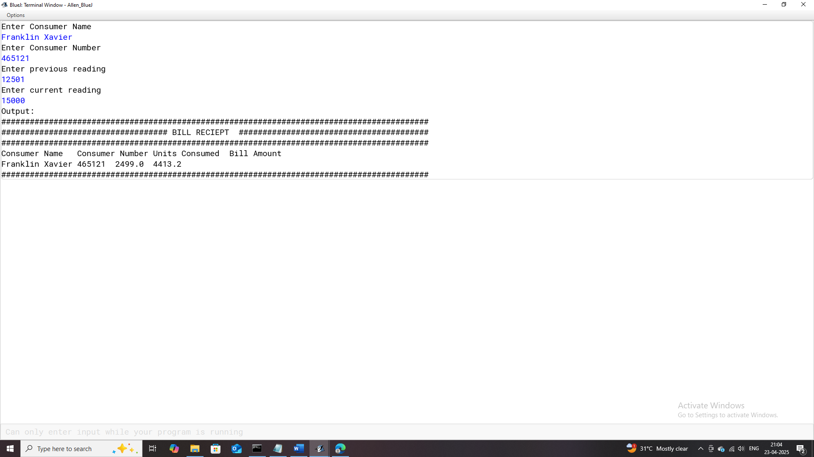

# **Program-15**

## **Program Name:** Salary

### **Problem Statement:** Design a Java program to calculate specific deductions and allowances based on an employee's basic salary.

* Provident Fund deduction (12% of basic salary).
* Education Allowance (20% of basic salary).
* House Rent Allowance (HRA) (10% of basic salary).

### **Java Code:**

import java.util.Scanner;

/**

* This program calculates and displays the PF deducted and amount recieved as HRA and EDU.

* Based on basic salary of the Employee

*

* @author (Allen Thomas.M)

* @author email (allenthomasmuttikal@gmail.com)

* @author git(https://github.com/allenthomasmuttikal/Java_Project)

* @version (v1.0)

*/

public class Salary

{

public static void main(String args[])

{

Scanner ob = new Scanner(System.in);

System.out.println("Enter Employee's Name");

String name = ob.nextLine();

System.out.println("Enter Employee's Basic Salary");

double basic_pay = ob.nextDouble();

double pf = (12.0/100.0) * basic_pay;

double edu = (20.0/100.0) * basic_pay;

double hra = (10.0/100.0) * basic_pay;

System.out.println("Output:");

System.out.println("The amount deducted as Provident Fund : "+pf);

System.out.println("The amount recieved for Education : "+edu);

System.out.println("The amount recieved for House Rent Allowance : "+hra);

}

}

### **Variables Used:**

| **Variable Name** | **Variable Datatype** | **Variable Description** |
| --- | --- | --- |
| **ob** | Scanner | Object used to read user input from the console. |
| **name** | String | Stores the name of the employee entered by the user. |
| **basic_pay** | double | Stores the basic salary of the employee entered by the user. |
| **pf** | double | Stores the calculated amount deducted as Provident Fund. |
| **edu** | double | Stores the calculated amount received for Education Allowance. |
| **hra** | double | Stores the calculated amount received for House Rent Allowance. |

### **Output:**

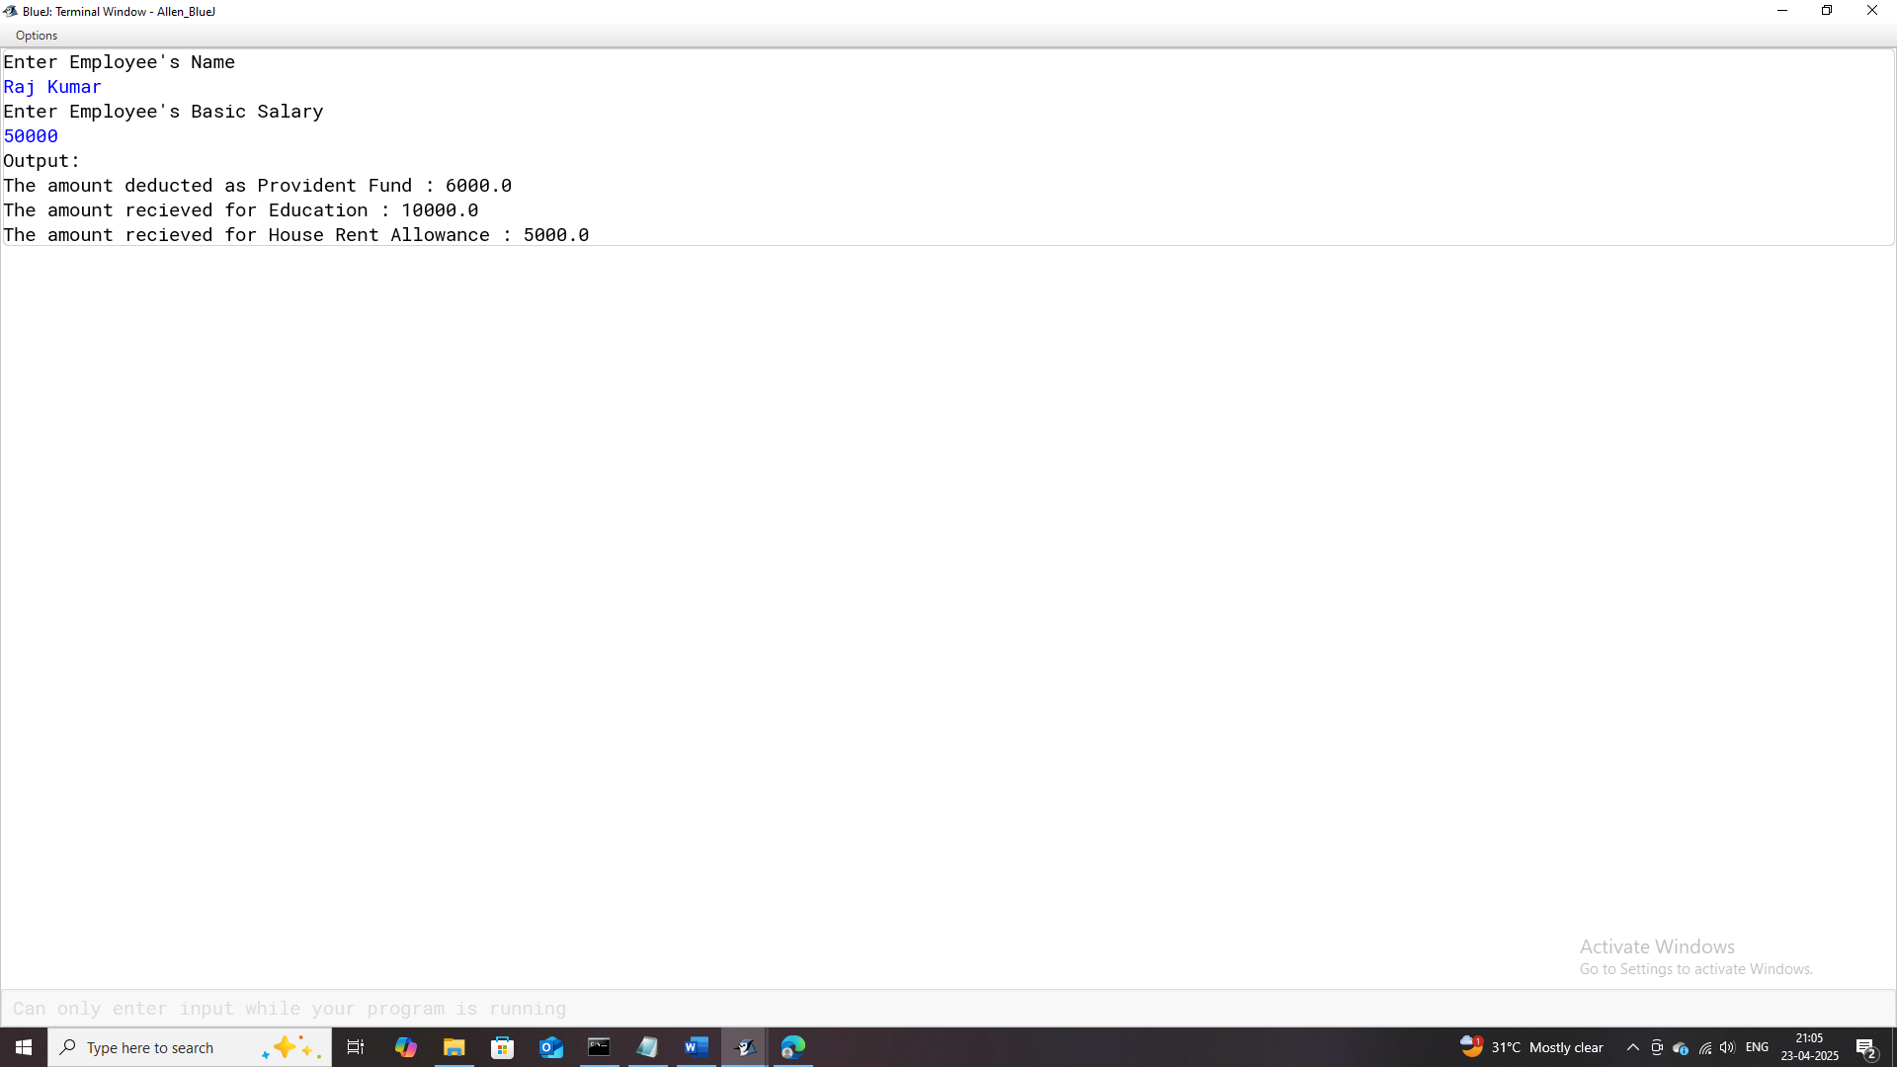

# **Program-16**

## **Program Name:** Basic_Pay

### **Problem Statement:** Develop a Java program to compute and display an employee's salary breakdown.

* Provident Fund (PF): 12.5% of the basic salary.
* Dearness Allowance (DA): 30% of the basic salary.
* House Rent Allowance (HRA): 15% of the basic salary.
* Gross Salary: Sum of the basic salary, DA, and HRA.
* Net Salary: Gross salary minus the PF deduction.

### **Java Code:**

import java.util.Scanner;

/**

* This program calculates and displays the Dearness Allowance,House Rent Allowance,Gross Salary,Provident Fund deducted and Net Salary.

* Based on the Basic Salary of the Employee

*

* @author (Allen Thomas.M)

* @author email (allenthomasmuttikal@gmail.com)

* @author git(https://github.com/allenthomasmuttikal/Java_Project)

* @version (v1.0)

*/

public class Basic_Pay

{

public static void main(String args[])

{

Scanner ob = new Scanner(System.in);

System.out.println("Enter Employee's Name");

String name = ob.nextLine();

System.out.println("Enter Employee's Basic Salary");

double basic_pay = ob.nextDouble();

double pf = (12.5/100.0) * basic_pay;

double da = (30.0/100.0) * basic_pay;

double hra = (15.0/100.0) * basic_pay;

double gross=basic_pay+da+hra;

double net=gross-pf;

System.out.println("Output:");

System.out.println("Employee's Name : "+name);

System.out.println("Basic Salary : "+basic_pay);

System.out.println("Dearness Allowance : "+da);

System.out.println("House Rent Allowance : "+hra);

System.out.println("Gross Salary : "+gross);

System.out.println("Provident Fund deducted : "+pf);

System.out.println("Net Salary : "+net);

}

}

### **Variables Used:**

| **Variable Name** | **Variable Datatype** | **Variable Description** |
| --- | --- | --- |
| **ob** | Scanner | Object used to read user input from the console. |
| **name** | String | Stores the name of the employee entered by the user. |
| **basic_pay** | double | Stores the basic salary of the employee entered by the user. |
| **pf** | double | Stores the calculated amount deducted as Provident Fund. |
| **da** | double | Stores the calculated Dearness Allowance. |
| **hra** | double | Stores the calculated House Rent Allowance. |
| **gross** | double | Stores the calculated Gross Salary by summing basic pay, DA, and HRA. |
| **net** | double |  |

### **Output:**

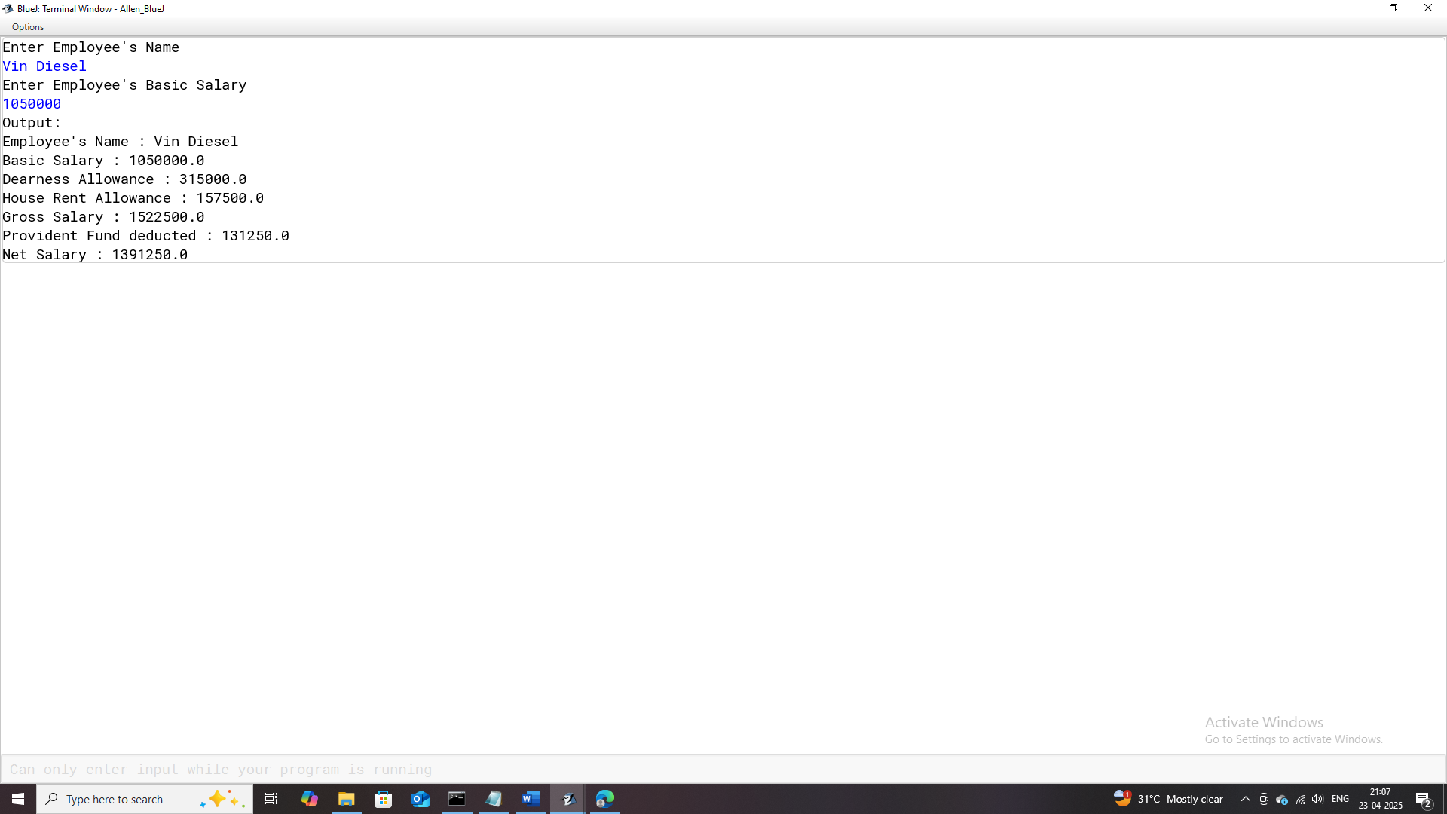

# **Program-17**

## **Program Name:** DAYS

### **Problem Statement:** Develop a Java program to convert a given number of days into its equivalent representation in years, months, and remaining days.

* The number of complete years.
* The number of complete months (remaining after computing years).
* The remaining days (after computing both years and months).

### **Java Code:**

import java.util.Scanner;

/**

* This program calculates and displays the number of years,months and days based on the number of days entered.

*

* @author (Allen Thomas.M)

* @author email (allenthomasmuttikal@gmail.com)

* @author git(https://github.com/allenthomasmuttikal/Java_Project)

* @version (v1.0)

*/

public class DAYS

{

public static void main(String args[])

{

Scanner ob = new Scanner(System.in);

System.out.println("Enter the number of days");

int days = ob.nextInt();

int year = days/365;

int months = (days%365) / 30;

int D = (days%365) % 30;

System.out.println("Output:");

System.out.println("The number of years are : "+year);

System.out.println("The number of months are : "+months);

System.out.println("The number of days are : "+D);

}

}

### **Variables Used:**

| **Variable Name** | **Variable Datatype** | **Variable Description** |
| --- | --- | --- |
| **ob** | Scanner | Object used to read user input from the console. |
| **days** | int | Stores the total number of days entered by the user. |
| **year** | int | Stores the calculated number of years derived from days. |
| **months** | int | Stores the calculated number of months derived from days. |
| **D** | int | Stores the remaining number of days after years and months are calculated. |

### **Output:**

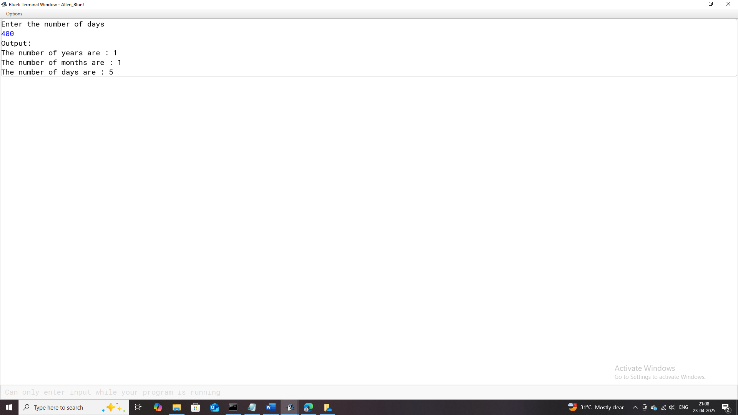

# **Program-18**

## **Program Name:** Interest

### **Problem Statement:** Design a Java program to calculate and compare Simple Interest (SI) and Compound Interest (CI) for a given principal amount, rate of interest, and duration in years.

### **Java Code:**

import java.util.Scanner;

/**

* This program calculates and displays the Simple Interest,Compound Interest and the Difference between the two.

*

* @author (Allen Thomas.M)

* @author email (allenthomasmuttikal@gmail.com)

* @author git(https://github.com/allenthomasmuttikal/Java_Project)

* @version (v1.0)

*/

public class Interest

{

public static void main(String args[])

{

Scanner ob = new Scanner(System.in);

System.out.println("Enter the principal");

double P = ob.nextDouble();

System.out.println("Enter the rate of interest");

double R = ob.nextDouble();

System.out.println("Enter the duration in years");

double D = ob.nextDouble();

double SI = (P*R*D) / 100.0;

double A = P * Math.pow((1+R / 100.0), D);

double CI = A - P;

double DIFF = CI - SI;

System.out.println("Output:");

System.out.println("The Simple Interest is : "+SI);

System.out.println("The Compound Interest is : "+CI);

System.out.println("The Difference between Simple and Compound Interest is : "+DIFF);

}

}

### **Variables Used:**

|  |  |  |  |  |  |  |  |  |  |  |  |  |  |  |  |  |  |  |  |  |  |  |  |  |  |  |  |
| --- | --- | --- | --- | --- | --- | --- | --- | --- | --- | --- | --- | --- | --- | --- | --- | --- | --- | --- | --- | --- | --- | --- | --- | --- | --- | --- | --- |
| | **Variable Name** | **Variable Datatype** | **Variable Description** | | --- | --- | --- | | **ob** | Scanner | Object used to read user input from the console. | | **P** | double | Stores the principal amount entered by the user. | | **R** | double | Stores the rate of interest entered by the user. | | **D** | double | Stores the duration in years entered by the user. | | **SI** | double | Stores the calculated Simple Interest using the formula (P⋅R⋅D)/100(P \cdot R \cdot D) / 100. | | **A** | double | Stores the accumulated amount using the formula P⋅(1+R/100)DP \cdot (1 + R / 100)^D. | | **CI** | double | Stores the calculated Compound Interest as the difference between A and P. | | **DIFF** | double | Stores the difference between Compound Interest (CI) and Simple Interest (SI). | |

### **Output:**

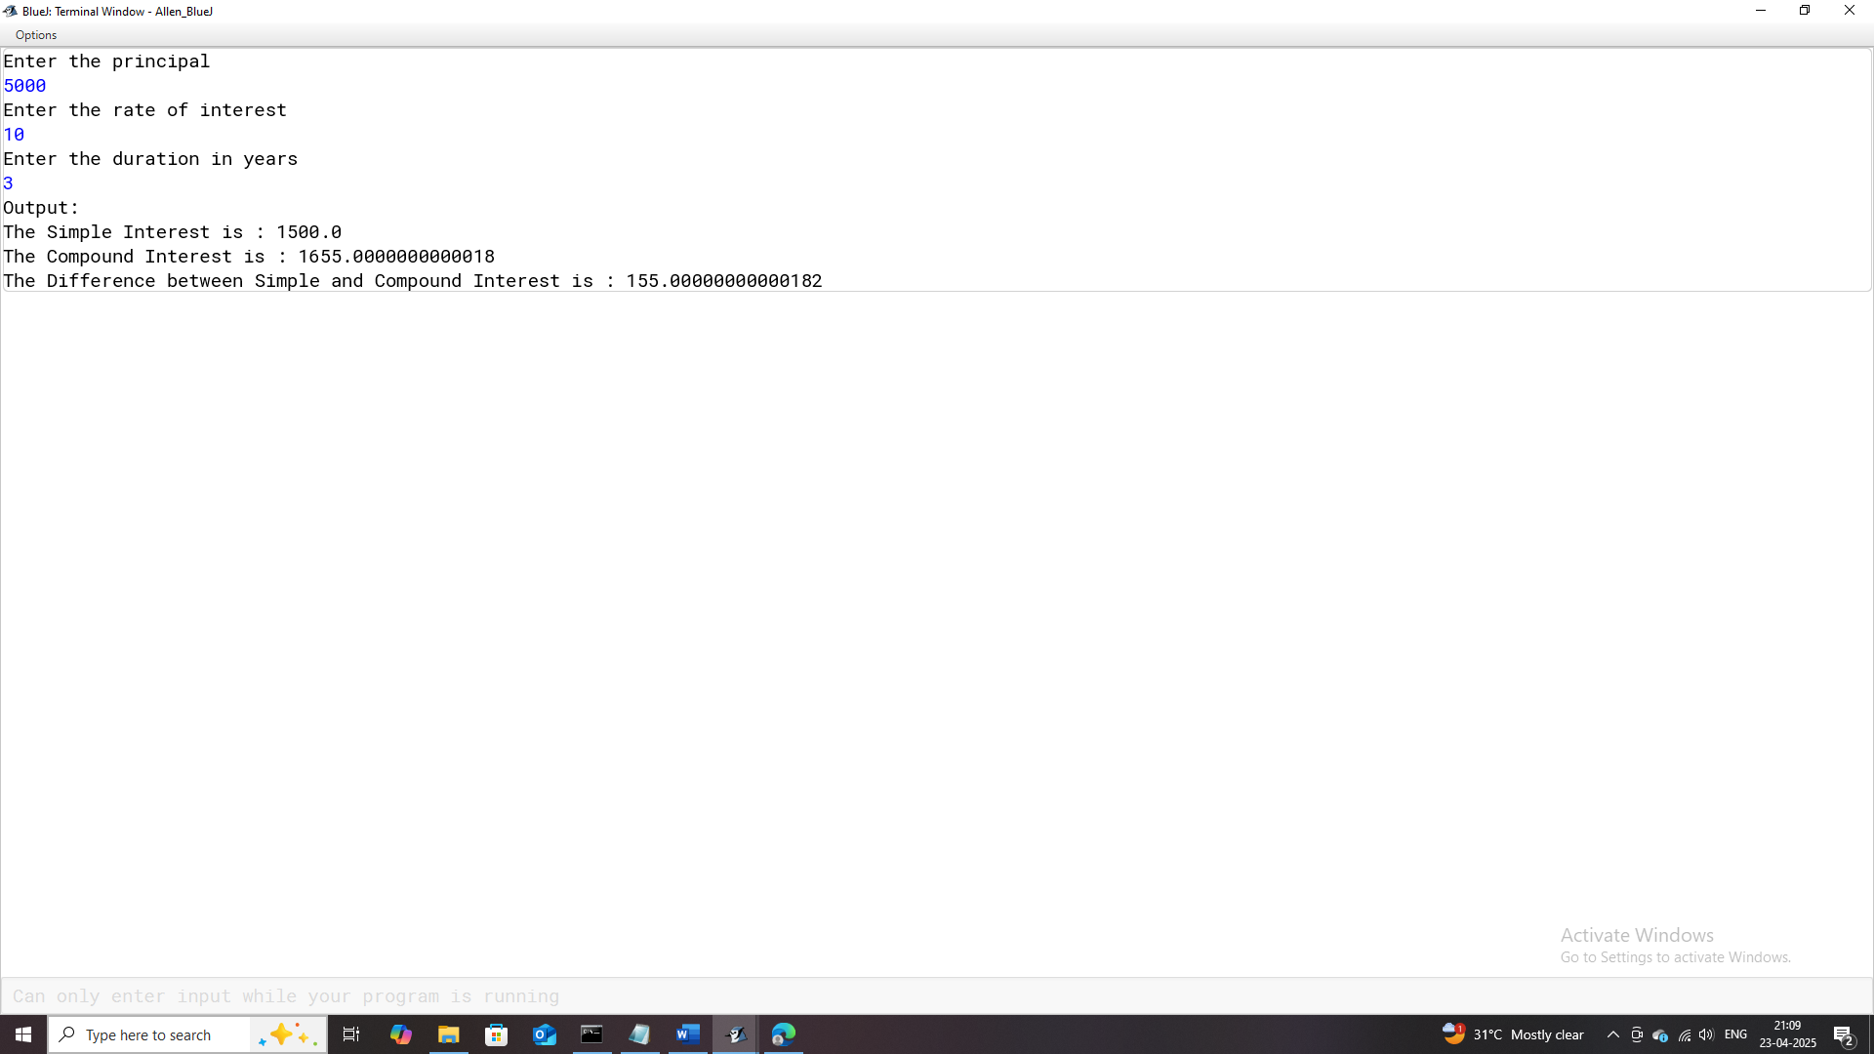

# **Program-19**

## **Program Name:** Grades

### **Problem Statement:** Develop a Java program that evaluates a student's academic performance based on their marks in Physics, Chemistry, and Biology.

* Distinction: Average percentage >= 80%.
* First Division: Average percentage between 60% and 79%.
* Second Division: Average percentage between 45% and 59%.
* Passed: Average percentage between 40% and 44%.
* Promotion Not Granted: Average percentage below 40%.

### **Java Code:**

import java.util.Scanner;

/**

* This program calculates and displays the grade and average percentage recieved by student in PCB

*

* @author (Allen Thomas.M)

* @author email (allenthomasmuttikal@gmail.com)

* @author git(https://github.com/allenthomasmuttikal/Java_Project)

* @version (v1.0)

*/

public class Grades

{

public static void main(String args[])

{

Scanner ob = new Scanner(System.in);

System.out.println("Enter Student's Name");

String name = ob.nextLine();

System.out.println("Enter Student's marks in Physics, Chemistry and Biology");

double p = ob.nextDouble();

double c = ob.nextDouble();

double b = ob.nextDouble();

double avg = (p+c+b) / 3;

System.out.println("Output:");

System.out.println("Student's Name : "+name);

if(avg >= 80)

System.out.println("Grade : You have recieved DISTINCTION");

else if(avg >= 60 && avg < 80)

System.out.println("Grade : You have recieved FIRST DIVISION");

else if(avg >= 45 && avg < 60)

System.out.println("Grade : You have recieved SECOND DIVISION");

else if(avg >= 40 && avg < 45)

System.out.println("Grade : You have PASSED");

else

System.out.println("Grade : PROMOTION NOT GRANTED");

System.out.println("Average Percentage : "+avg+"%");

}

}

### **Variables Used:**

| **Variable Name** | **Variable Datatype** | **Variable Description** |
| --- | --- | --- |
| **ob** | Scanner | Object used to read user input from the console. |
| **name** | String | Stores the name of the student entered by the user. |
| **p** | double | Stores the marks obtained by the student in Physics. |
| **c** | double | Stores the marks obtained by the student in Chemistry. |
| **b** | double | Stores the marks obtained by the student in Biology. |
| **avg** | double | Stores the calculated average percentage of marks across Physics, Chemistry, and Biology. |

### **Output:**

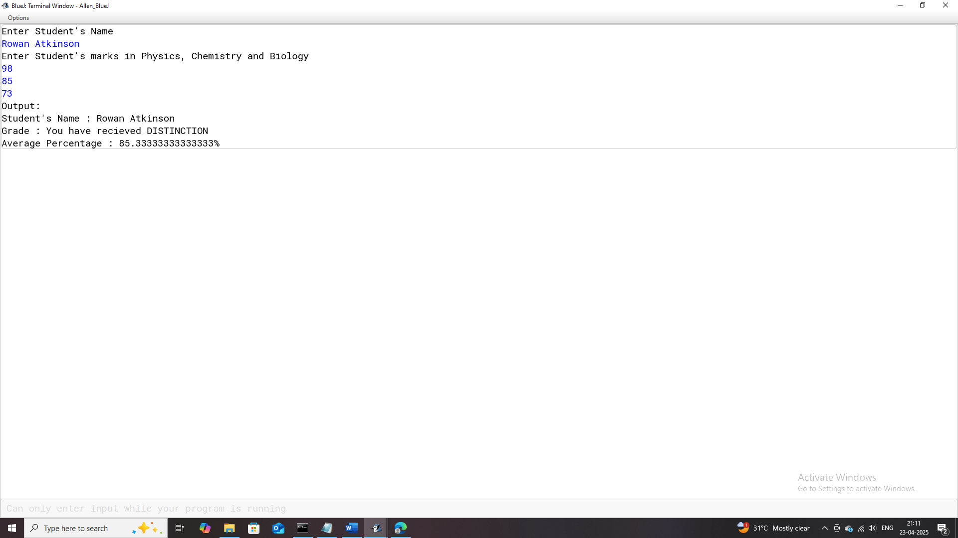

# **Program-20**

## **Program Name:** Electronics_World

### **Problem Statement**: Create a Java program to calculate the total amount payable for the purchase of either an air-conditioner or an LCD TV.

Based on the product choice and the purchase amount, compute the following:

* Discount: A varying percentage discount based on slabs specific to each product.
* Retail Price: The purchase amount minus the discount.
* Tax: A fixed rate of 12.5% on the retail price.
* Total Payable Amount: The sum of retail price and tax.

### **Java Code:**

import java.util.Scanner;

/**

* This program calculates and displays the Recipt Slip for Purchase of Electronics Goods (Air-Conditioner / LCD Tv).

* The Net Cost for the product depends on the Discount obtained based on the Purchase Price and Tax.

*

* @author (Allen Thomas.M)

* @author email (allenthomasmuttikal@gmail.com)

* @author git(https://github.com/allenthomasmuttikal/Java_Project)

* @version (v1.0)

*/

public class Electronics_World

{

public static void main(String args[])

{

Scanner ob = new Scanner(System.in);

System.out.println("Enter Consumer Name");

String name = ob.nextLine();

System.out.println("The Choices are Air-Conditioner and LCD Tv.\nEnter:\n1. for Air-Conditioner\n2. for LCD Tv");

int choice = ob.nextInt();

double purchase = 0.0d;

double discount = 0.0d;

double retail_price = 0.0d;

double tax = 0.0d;

double payable_amt = 0.0d;

if(choice == 1)

{

System.out.println("Enter amount of Air-Conditioner");

purchase = ob.nextDouble();

if(purchase <= 20000)

discount = purchase*5.0/100.0;

else if(purchase > 20000 && purchase <= 40000)

discount = purchase * (7.5/100.0);

else if(purchase > 40000 && purchase <= 60000)

discount = purchase * (10.0/100.0);

else

discount = purchase * (12.0/100.0);

retail_price = purchase-discount;

tax = retail_price * (12.5/100.0);

payable_amt = retail_price + tax;

System.out.println("#########################################################################");

System.out.println("######################### Reciept Slip ##################################");

System.out.println("#########################################################################");

System.out.println("Consumer's name : "+name);

System.out.println("Price of Air-Conditioner : "+purchase);

System.out.println("The Discount : "+discount);

System.out.println("The tax : "+tax);

System.out.println("The amount to be paid : "+payable_amt);

System.out.println("#########################################################################");

}

else if (choice == 2)

{

System.out.println("Enter amount of LCD Tv");

purchase = ob.nextDouble();

if(purchase <= 20000)

discount = purchase * (2.5/100.0);

else if(purchase > 20000 && purchase <= 40000)

discount = purchase * (5.0/100.0);

else if(purchase > 40000 && purchase <= 60000)

discount = purchase * (7.0/100.0);

else

discount = purchase * (8.5/100.0);

retail_price = purchase - discount;

tax = retail_price * (12.5/100.0);

payable_amt = retail_price + tax;

System.out.println("#########################################################################");

System.out.println("######################### Reciept Slip ##################################");

System.out.println("#########################################################################");

System.out.println("Consumer's name : "+name);

System.out.println("Price of LCD Tv : "+purchase);

System.out.println("The Discount : "+discount);

System.out.println("The tax : "+tax);

System.out.println("The amount to be paid : "+payable_amt);

System.out.println("#########################################################################");

}

else

System.out.println("Invalid Choice");

}

}

### **Variables Used:**

| **Variable Name** | **Variable Datatype** | **Variable Description** |
| --- | --- | --- |
| **ob** | Scanner | Object used to read user input from the console. |
| **name** | String | Stores the name of the consumer entered by the user. |
| **choice** | int | Stores the choice input by the user to select between Air-Conditioner and LCD Tv. |
| **purchase** | double | Stores the purchase amount of the selected product. |
| **discount** | double | Stores the calculated discount based on the purchase amount and product type. |
| **retail_price** | double | Stores the price of the product after applying the discount. |
| **tax** | double | Stores the calculated tax on the discounted price. |
| **payable_amt** | double | Stores the total amount to be paid including tax after discount. |

### **Output:**

.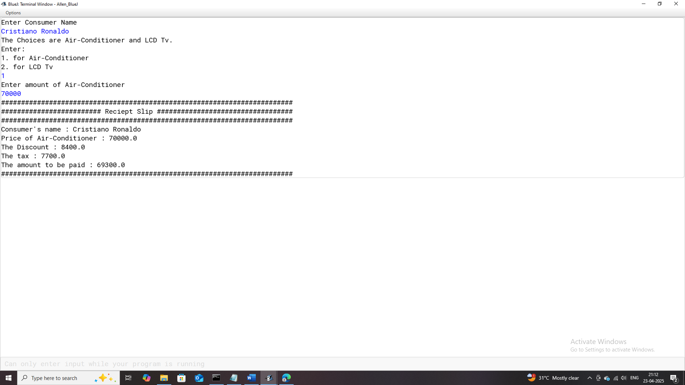

# **Program-21**

## **Program Name:** Switch_Case_1

### **Problem Statement:** Design a Java program that offers three distinct functionalities based on user selection using a switch-case construct:

### Calculate and display the square root of a user-provided number.

### Compare two user-provided numbers and display the larger of the two.

### Calculate and display the area of a circle based on a user-provided radius.

### **Java Code:**

import java.util.Scanner;

/**

* This program calculates and displays various tasks based on the user's choice.

* The 3 options are:

* 1.square root of a number

* 2.largest of any 2 numbers

* 3.area of a circle

*

* @author (Allen Thomas.M)

* @author email (allenthomasmuttikal@gmail.com)

* @author git(https://github.com/allenthomasmuttikal/Java_Project)

* @version (v1.0)

*/

public class Switch_Case_1

{

public static void main(String args[])

{

Scanner ob = new Scanner(System.in);

System.out.println("Enter 1 to find the square root of a number");

System.out.println("Enter 2 to find the largest of any 2 numbers");

System.out.println("Enter 3 to find the area of a circle");

int choice = ob.nextInt();

switch(choice)

{

case 1:System.out.println("Enter a number");

int a = ob.nextInt();

System.out.println("Output:");

System.out.println("The Square Root of "+a+" is : "+Math.sqrt(a));

break;

case 2:System.out.println("Enter any 2 numbers");

int b = ob.nextInt();

int c = ob.nextInt();

System.out.println("Output:");

if(b > c)

System.out.println(b+" is greater than "+c);

else

System.out.println(c+" is greater than "+b);

break;

case 3:System.out.println("Enter the radius");

double radius = ob.nextDouble();

double pi = 3.14d;

double area = pi * radius * radius;

System.out.println("Output:");

System.out.println("The area of circle with radius "+radius+" is : "+area);

break;

default:System.out.println("Invalid Input");

}

}

}

### **Variables Used:**

| **Variable Name** | **Variable Datatype** | **Variable Description** |
| --- | --- | --- |
| **ob** | Scanner | Object used to read user input from the console. |
| **choice** | int | Stores the user’s choice of task (square root, largest number, or circle area). |
| **a** | int | Stores the number input for calculating the square root. |
| **b** | int | Stores the first number input for comparing two numbers. |
| **c** | int | Stores the second number input for comparing two numbers. |
| **radius** | double | Stores the radius of the circle input by the user. |
| **pi** | double | Stores the constant value of π (3.14) used for calculating the area of the circle. |
| **area** | double | Stores the calculated area of the circle using the formula π⋅radius2π \cdot \text{radius}^2. |

### **Output:**

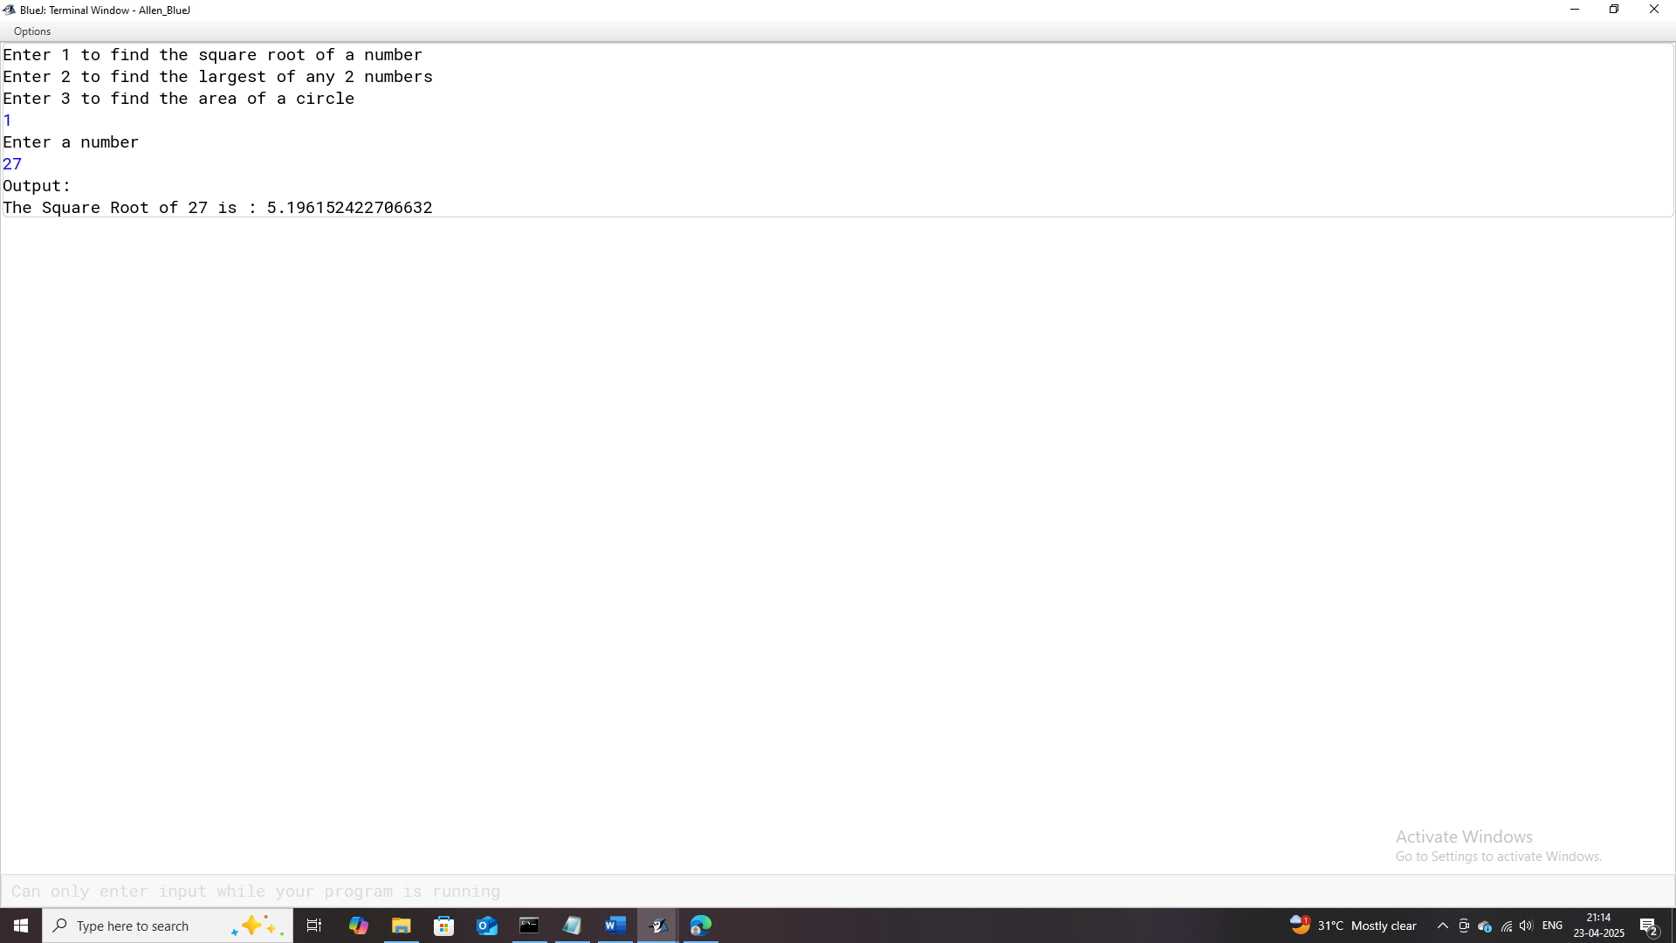

# **Program-22**

## **Program Name:** Switch_Case_2

### **Problem Statement:** Develop a Java program that allows the user to choose between various functionalities using a menu-driven system implemented with switch-case statements. The program should prompt the user to select one of the following options:

### Print numbers from 1 to 10.

### Print numbers from 10 to 1.

### Reverse a given number and display it.

### Count and display the number of digits in a given number.

### Calculate and display the sum of the digits of a given number.

### Calculate and display the factorial of a given number.

### **Java Code:**

import java.util.Scanner;

/**

*This program calculates and displays various tasks based on the user's choice.

* The 6 options are:

* 1.print numbers from 1-10

* 2.print numbers from 10-1

* 3.flip/reverse a number

* 4.count and display the number of digits in a number

* 5.find and display the sum of the digits of a number

* 6.find and display the factorial of a number

*

* @author (Allen Thomas.M)

* @author email (allenthomasmuttikal@gmail.com)

* @author git(https://github.com/allenthomasmuttikal/Java_Project)

* @version (v1.0)

*/

public class Switch_Case_2

{

public static void main(String args[])

{

Scanner ob = new Scanner(System.in);

System.out.println("Enter 1 to print numbers from 1-10");

System.out.println("Enter 2 to print numbers from 10-1");

System.out.println("Enter 3 to flip/reverse a number");

System.out.println("Enter 4 to count and display the number of digits in a number");

System.out.println("Enter 5 to find and display the sum of the digits of a number");

System.out.println("Enter 6 to find and display the factorial of a number");

int choice = ob.nextInt();

switch(choice)

{

case 1: int a = 1;

System.out.println("Output:");

while(a <= 10)

{

System.out.println(a);

a++;

}

break;

case 2: int b = 10;

System.out.println("Output:");

while(b >= 1)

{

System.out.println(b);

b--;

}

break;

case 3: System.out.println("Enter a number");

int num = ob.nextInt();

System.out.println("Output:");

System.out.println("The reversed number of "+num+" is : ");

while(num != 0)

{

int c = num % 10;

System.out.print(c);

num /= 10;

}

break;

case 4: System.out.println("Enter a number");

int number = ob.nextInt();

int temp = number;

int count = 0;

System.out.println("Output:");

while(number != 0)

{

count++;

number /= 10;

}

System.out.println("The number of digits in "+temp+" is : "+count);

break;

case 5: System.out.println("Enter a number");

int n = ob.nextInt();

int j = n;

int sum = 0;

while(n != 0)

{

sum += n % 10;

n /= 10;

}

System.out.println("Output:");

System.out.println("The sum of the digits in "+j +" is : "+sum);

break;

case 6: System.out.println("Enter a number");

int d = ob.nextInt();

long factorial = 1;

int i = 1;

while(i <= d)

{

factorial *= i;

i++;

}

System.out.println("Output:");

System.out.println("The factorial of "+d+" is : "+factorial);

break;

default:System.out.println("Invalid Input");

}

}

}

### **Variables Used:**

| **Variable Name** | **Variable Datatype** | **Variable Description** |
| --- | --- | --- |
| **ob** | Scanner | Object used to read user input from the console. |
| **choice** | Int | Stores the user’s choice of task (1–6 options). |
| **a** | Int | Stores the current number in the range 1–10 for printing. |
| **b** | Int | Stores the current number in the range 10–1 for printing. |
| **num** | Int | Stores the number input by the user for reversing. |
| **c** | Int | Stores individual digits during the reversal of num. |
| **number** | Int | Stores the number input by the user for digit counting. |
| **temp** | Int | Stores the original value of number for display purposes. |
| **count** | Int | Stores the count of digits in the input number. |
| **n** | Int | Stores the number input by the user for summing its digits. |
| **j** | Int | Stores the original value of n for display purposes. |
| **sum** | Int | Stores the sum of the digits of the input number n. |
| **d** | Int | Stores the number input by the user for factorial calculation. |
| **factorial** | Long | Stores the calculated factorial of the input number d. |
| **i** | Int | Loop counter variable for factorial calculation. |

### **Output:**

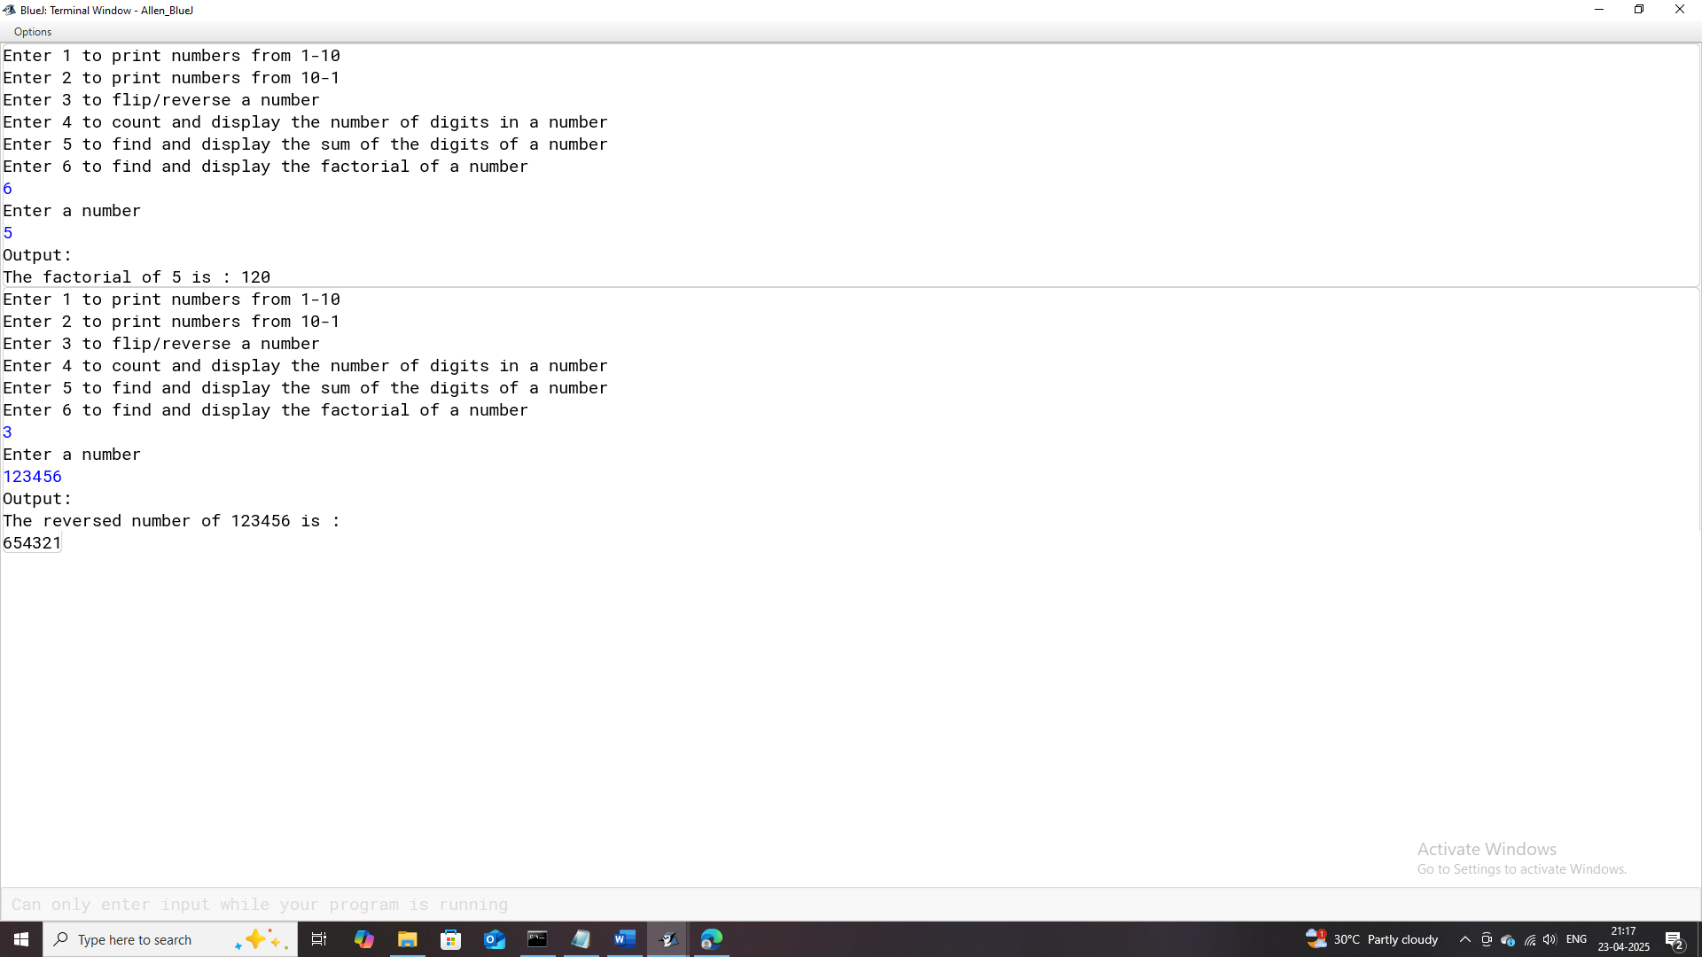

# **Program-23**

## **Program Name:** Switch_Case_3

### **Problem Statement:** Develop a menu-driven Java program that allows users to check for specific mathematical properties of numbers. The program should prompt the user to select one of the following options:

### Check if a number is a Palindrome Number.

### Check if a number is an Armstrong Number.

### Check if a number is a Prime Number.

### Check if a number is a Perfect Number.

### Check if a number is a Harshad Number.

### Check if a number is a Kaprekar Number.

### Check if a number is an Automorphic Number.

### **Java Code:**

import java.util.Scanner;

/**

* This program calculates and displays various tasks based on the user's choice.

* There are a total of 7 different choices

*

* @author (Allen Thomas.M)

* @author email (allenthomasmuttikal@gmail.com)

* @author git(https://github.com/allenthomasmuttikal/Java_Project)

* @version (v1.0)

*/

public class Switch_Case_3

{

public static void main(String args[])

{

Scanner ob = new Scanner(System.in);

System.out.println("Enter 1 to check if a number is a Palindrome Number");

System.out.println("Enter 2 to check if a number is an Armstrong Number");

System.out.println("Enter 3 to check if a number is a Prime Number");

System.out.println("Enter 4 to check if a number is a Perfect Number");

System.out.println("Enter 5 to check if a number is a Harshad Number");

System.out.println("Enter 6 to check if a number is a Kaprekar Number");

System.out.println("Enter 7 to check if a number is an Automorphic Number");

int choice = ob.nextInt();

switch(choice)

{

case 1: System.out.println("Enter a number");

int num = ob.nextInt();

int temp = num;

int reverse = 0;

System.out.println("Output:");

while(temp != 0)

{

int r = temp % 10;

reverse = reverse * 10 + r;

temp /= 10;

}

if(num == reverse)

System.out.println(num+" is a Palindrome Number");

else

System.out.println(num+" is not a Palindrome Number");

break;

case 2: System.out.println("Enter a number");

int number = ob.nextInt();

int tem = number;

int rem = 0;

int sum = 0;

System.out.println("Output:");

while(tem != 0)

{

rem = tem % 10;

sum += (int)Math.pow(rem,3);

tem /= 10;

}

if(sum == number)

System.out.println(number+" is an Armstrong Number");

else

System.out.println(number+" is not an Armstrong Number");

break;

case 3: System.out.println("Enter a number");

int n = ob.nextInt();

int i = 1;

int count = 0;

System.out.println("Output:");

while(i <= n)

{

if(n % i == 0)

count++;

i++;

}

if(count == 2)

System.out.println(n+" is a Prime Number");

else

System.out.println(n+" is not a Prime Number");

break;

case 4: System.out.println("Enter a number");

int a = ob.nextInt();

int s = 0;

int j = 1;

System.out.println("Output:");

while(j < a)

{

if(a % j == 0)

s+=j;

j++;

}

if(s == a)

System.out.println(a+" is a Perfect Number");

else

System.out.println(a+" is not a Perfect Number");

break;

case 5: System.out.println("Enter a number");

int b = ob.nextInt();

int t = b;

int remainder = 0;

int summation = 0;

System.out.println("Output:");

while(t != 0)

{

remainder = t % 10;

summation+=remainder;

t /= 10;

}

if(b % summation == 0)

System.out.println(b+" is a Harshad Number");

else

System.out.println(b+" is not a Harshad Number");

break;

case 6: System.out.println("Enter a number");

int c = ob.nextInt();

int tempor = c;

int add = 0; int first = 0; int second = 0; int tally = 0; int square = 0;

while(tempor != 0)

{

tally++;

tempor /= 10;

}

square = c * c;

first = square / (int)Math.pow(10,tally);

second = square % (int)Math.pow(10,tally);

add = first + second;

System.out.println("Output:");

if(c == add)

System.out.println(c+" is a Kaprekar Number");

else

System.out.println(c+" is not a Kaprekar Number");

break;

case 7: System.out.println("Enter a number");

int d = ob.nextInt();

int sq = 0; int temporary = d; int reckon = 0; int last = 0;

while(temporary != 0)

{

reckon++;

temporary /= 10;

}

sq = d * d;

System.out.println("The square value of "+d+" is : "+sq);

last = sq % (int)Math.pow(10,reckon);

System.out.println("Output:");

if(d == last)

System.out.println(d+" is an Automorphic Number");

else

System.out.println(d+" is not an Automorphic Number");

break;

default:System.out.println("Invalid Input");

}

}

}

### **Variables Used:**

| **Variable Name** | **Variable Datatype** | **Variable Description** |
| --- | --- | --- |
| **ob** | Scanner | Object used to read user input from the console. |
| **choice** | Int | Stores the user’s choice to execute one of the seven tasks (e.g., Palindrome check, Armstrong number, etc.). |
| **num** | Int | Stores the number input by the user for checking if it is a Palindrome. |
| **temp** | Int | Temporarily holds the value of num during processing. |
| **reverse** | Int | Stores the reversed version of the number for Palindrome check. |
| **r** | Int | Stores the remainder during the reversal of a number. |
| **number** | Int | Stores the number input by the user for Armstrong number check. |
| **tem** | Int | Temporarily holds the value of number during processing for Armstrong number. |
| **rem** | Int | Stores the remainder during the calculation of Armstrong number. |
| **sum** | Int | Stores the sum of the digits raised to the power three for Armstrong number check. |
| **n** | Int | Stores the number input by the user for Prime number check. |
| **i** | Int | Loop counter for checking the factors of n in Prime number determination. |
| **count** | Int | Counts the number of factors for Prime number determination. |
| **a** | Int | Stores the number input by the user for Perfect number check. |
| **s** | Int | Stores the sum of divisors of a for Perfect number determination. |
| **j** | Int | Loop counter for summing up divisors of a. |
| **b** | Int | Stores the number input by the user for Harshad number check. |
| **t** | Int | Temporarily holds the value of b during processing for Harshad number check. |
| **remainder** | Int | Stores the remainder during digit summation for Harshad number check. |
| **summation** | Int | Stores the sum of the digits of b for Harshad number check. |
| **c** | Int | Stores the number input by the user for Kaprekar number check. |
| **tempor** | Int | Temporarily holds the value of c during processing for Kaprekar number check. |
| **add** | Int | Stores the sum of the split parts of the squared number for Kaprekar number check. |
| **first** | Int | Stores the first part of the squared number in Kaprekar number check. |
| **second** | Int | Stores the second part of the squared number in Kaprekar number check. |
| **tally** | Int | Counts the number of digits in the number c for Kaprekar number check. |
| **square** | Int | Stores the square of the number c for Kaprekar number check. |
| **d** | Int | Stores the number input by the user for Automorphic number check. |
| **sq** | Int | Stores the square of d for Automorphic number check. |
| **temporary** | Int | Temporarily holds the value of d during processing for Automorphic number check. |
| **reckon** | Int | Counts the number of digits in the number d for Automorphic number check. |
| **last** | Int | Stores the last part of the squared number to compare with d in Automorphic number check. |

### **Output:**

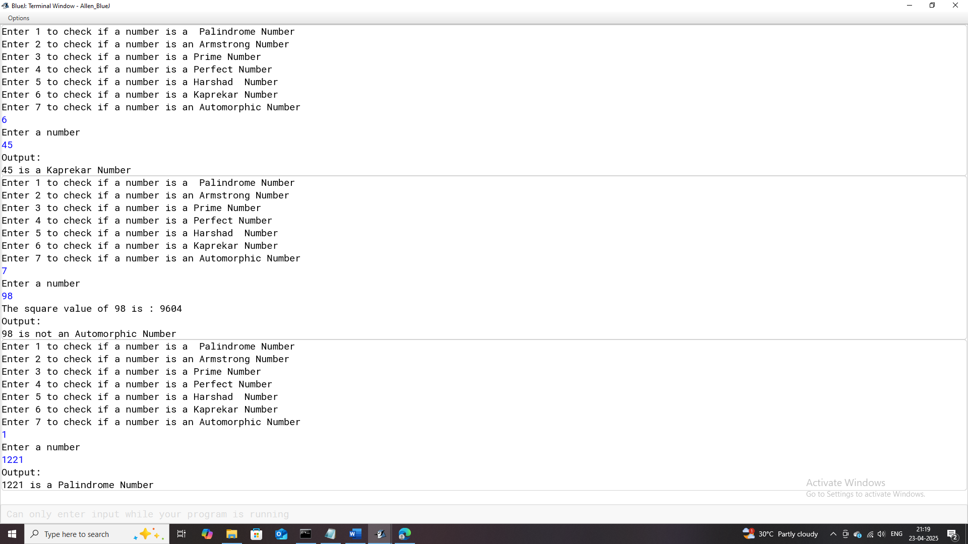

# **Program-24**

## **Program Name:** Switch_Case_4

### **Problem Statement:** Develop a menu-driven Java program that performs various operations based on user selection using a switch-case construct. The program should prompt the user to choose one of the following functionalities:

### Print the factors of a given number.

### Calculate and display the sum of the factors of a given number.

### Generate and print the Fibonacci series up to a specified limit.

### Print all odd numbers up to a specified limit.

### Print odd numbers in reverse order from 30 to 15.

### Calculate and display the sum of the digits in odd positions of a given number.

### **Java Code:**

import java.util.Scanner;

/**

* This program calculates and displays various tasks based on the user's choice.

* There are a total of 6 choices.

*

* @author (Allen Thomas.M)

* @author email (allenthomasmuttikal@gmail.com)

* @author git(https://github.com/allenthomasmuttikal/Java_Project)

* @version (v1.0)

*/

public class Switch_Case_4

{

public static void main(String args[])

{

Scanner ob = new Scanner(System.in);

System.out.println("Enter 1 to print the factors of a number");

System.out.println("Enter 2 to print the sum of the factors of a number");

System.out.println("Enter 3 to print the fibonacci series till a limit ");

System.out.println("Enter 4 to print the odd numbers till a limit");

System.out.println("Enter 5 to print the odd numbers in the reverse order from 30-15");

System.out.println("Enter 6 to find the sum of the digits in odd positions of a number");

int choice = ob.nextInt();

switch(choice)

{

case 1: System.out.println("Enter a number");

int num = ob.nextInt();

int i = 1;

System.out.println("Output:");

while(i <= num)

{

if(num % i == 0)

System.out.println(i);

i++;

}

break;

case 2: System.out.println("Enter a number");

int number = ob.nextInt();

int j = 1; int sum = 0;

while(j <= number)

{

if(number % j == 0)

sum+=j;

j++;

}

System.out.println("Output:");

System.out.println("The sum of the factors of "+number+" is : "+sum);

break;

case 3: System.out.println("Enter a limit");

int limit=ob.nextInt();

int a = 0; int b = 1; int c = 3;

System.out.println("Output:");

System.out.print(a+","+b);

while(c <= limit)

{

int d = a + b;

System.out.print(","+d);

a = b;

b = d;

c++;

}

break;

case 4: System.out.println("Enter a limit");

int lim = ob.nextInt();

int k = 1;

System.out.println("Output:");

while(k <= lim)

{

if(k % 2 != 0)

System.out.println(k);

k++;

}

break;

case 5: int l = 30;

int m = 15;

System.out.println("Output:");

while(l >= m)

{

if(l % 2 != 0)

System.out.print (l+",");

l--;

}

break;

case 6: System.out.println("Enter a number");

int e = ob.nextInt();

int rem = 0;

int count = 0;

int temp = e;

int t = temp;

int summation = 0;

while(temp != 0)

{

count++;

temp /= 10;

}

while(e != 0)

{

rem = e % 10;

if(count % 2 != 0)

summation+=rem;

e /= 10;

count--;

}

System.out.println("Output:");

System.out.println("The sum of the digits in odd positions of "+t+" is : "+summation );

break;

default:System.out.println("Invalid Input");

}

}

}

### **Variables Used:**

| **Variable Name** | **Variable Datatype** | **Variable Description** |
| --- | --- | --- |
| **ob** | Scanner | Object used to read user input from the console. |
| **choice** | Int | Stores the user’s choice for executing one of the six tasks. |
| **num** | Int | Stores the number input by the user for printing its factors. |
| **i** | Int | Loop counter for finding and printing factors of num. |
| **number** | Int | Stores the number input by the user for summing its factors. |
| **j** | Int | Loop counter for finding factors and summing them for number. |
| **sum** | Int | Stores the calculated sum of the factors of number. |
| **limit** | Int | Stores the upper limit for generating the Fibonacci series. |
| **a** | Int | Stores the first Fibonacci number during series generation. |
| **b** | Int | Stores the second Fibonacci number during series generation. |
| **c** | Int | Loop counter for generating numbers in the Fibonacci series. |
| **d** | Int | Temporarily stores the sum of a and b during Fibonacci generation. |
| **lim** | Int | Stores the upper limit for generating odd numbers. |
| **k** | Int | Loop counter for printing odd numbers up to lim. |
| **l** | Int | Stores the starting value for printing odd numbers in reverse. |
| **m** | Int | Stores the ending value for printing odd numbers in reverse. |
| **e** | Int | Stores the number input by the user for summing its odd-positioned digits. |
| **rem** | Int | Stores the remainder during digit extraction from e. |
| **count** | Int | Counts the total digits in e to determine their positions. |
| **temp** | Int | Temporarily holds the value of e during digit position count. |
| **t** | Int | Stores the original value of e for displaying output. |
| **summation** | Int | Stores the sum of digits in odd positions of e. |

### **Output:**

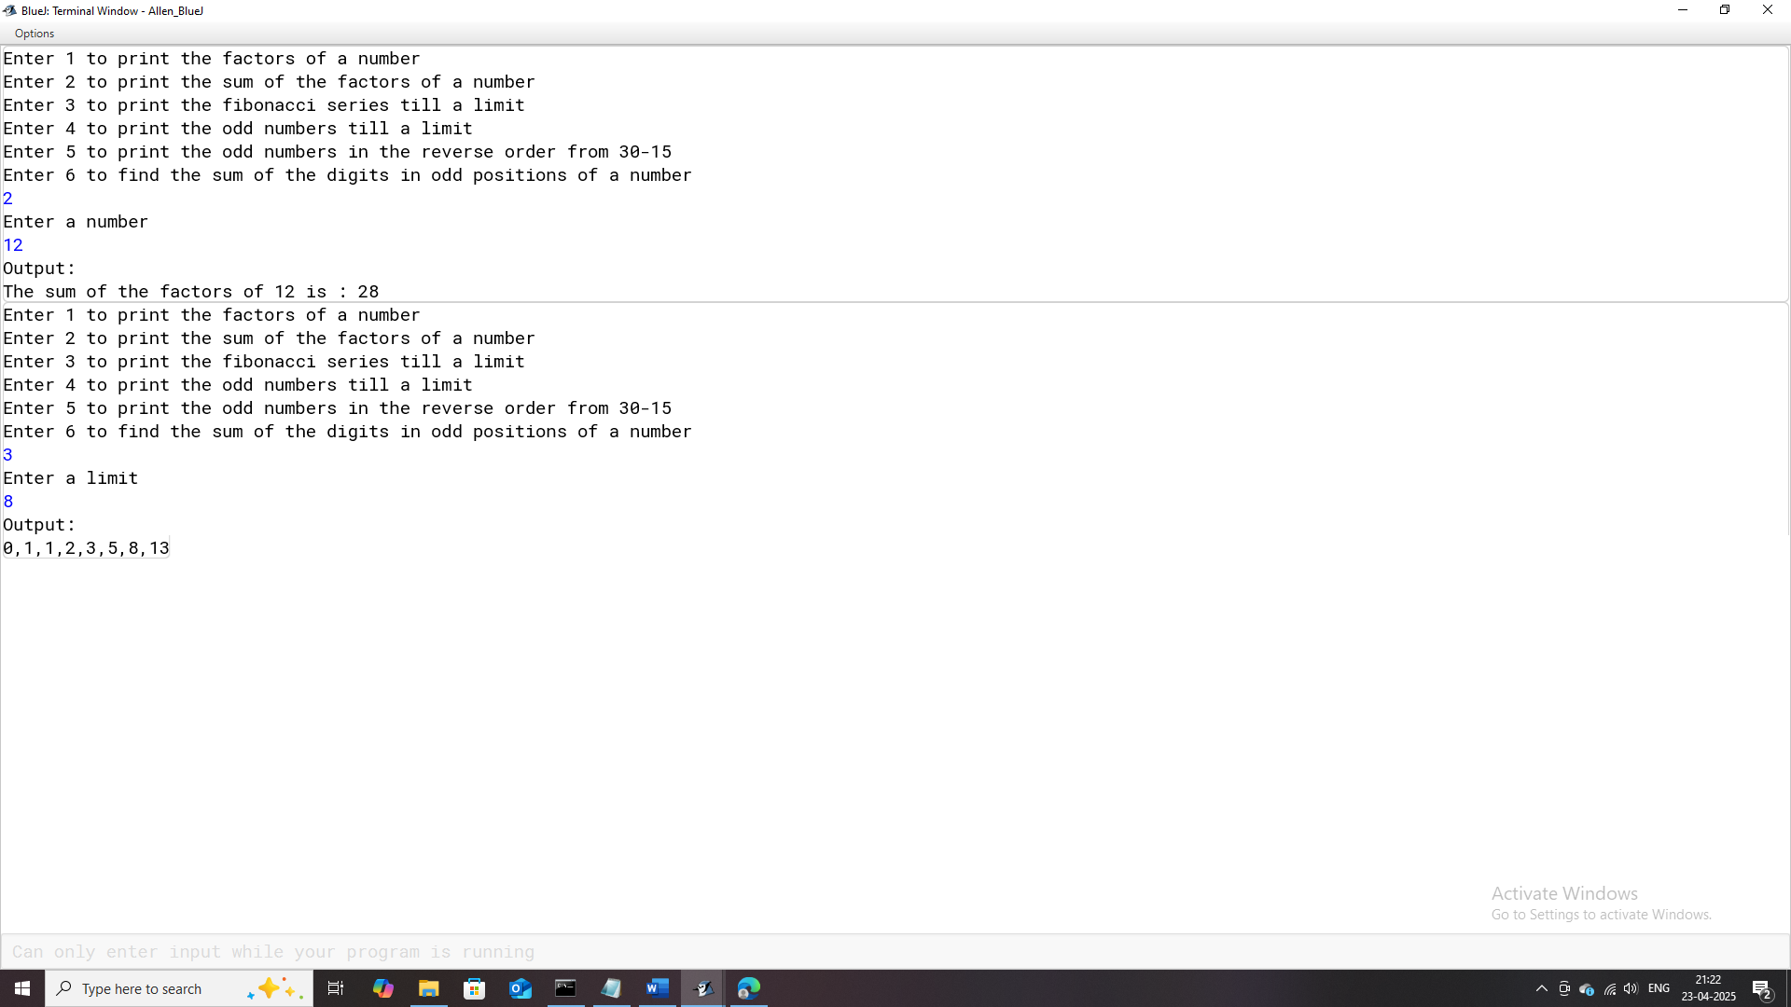

# **Program-25**

## **Program Name:** Alphabets

### **Problem Statement:**

### **Java Code:**

import java.util.Scanner;

/**

* This program displays, either all the upper case(A-Z) or lower case(a-z) alphabets depending on the user's choice.

*

* @author (Allen Thomas.M)

* @author email (allenthomasmuttikal@gmail.com)

* @author git(https://github.com/allenthomasmuttikal/Java_Project)

* @version (v1.0)

*/

public class Alphabets

{

public static void main(String args[])

{

Scanner ob = new Scanner(System.in);

System.out.println("Enter 1 to print all the upper case alphabets from A-Z");

System.out.println("Enter 2 to print all the lower case alphabets from a-z");

int choice = ob.nextInt();

switch(choice)

{

case 1: int a = 65;

System.out.println("Output:");

while(a <= 90)

{

System.out.print((char)(a));

a++;

}

break;

case 2: int b = 97;

System.out.println("Output:");

while(b <= 122)

{

System.out.print((char)(b));

b++;

}

break;

default:System.out.println("Invalid Input");

}

}

}

### **Variables Used:**

| **Variable Name** | **Variable Datatype** | **Variable Description** |
| --- | --- | --- |
| **ob** | Scanner | Object used to read user input from the console. |
| **choice** | int | Stores the user's choice to print either uppercase or lowercase alphabets. |
| **a** | int | Stores the ASCII value for uppercase alphabets, iterates from 'A' (65) to 'Z' (90). |
| **b** | int | Stores the ASCII value for lowercase alphabets, iterates from 'a' (97) to 'z' (122). |

### **Output:**

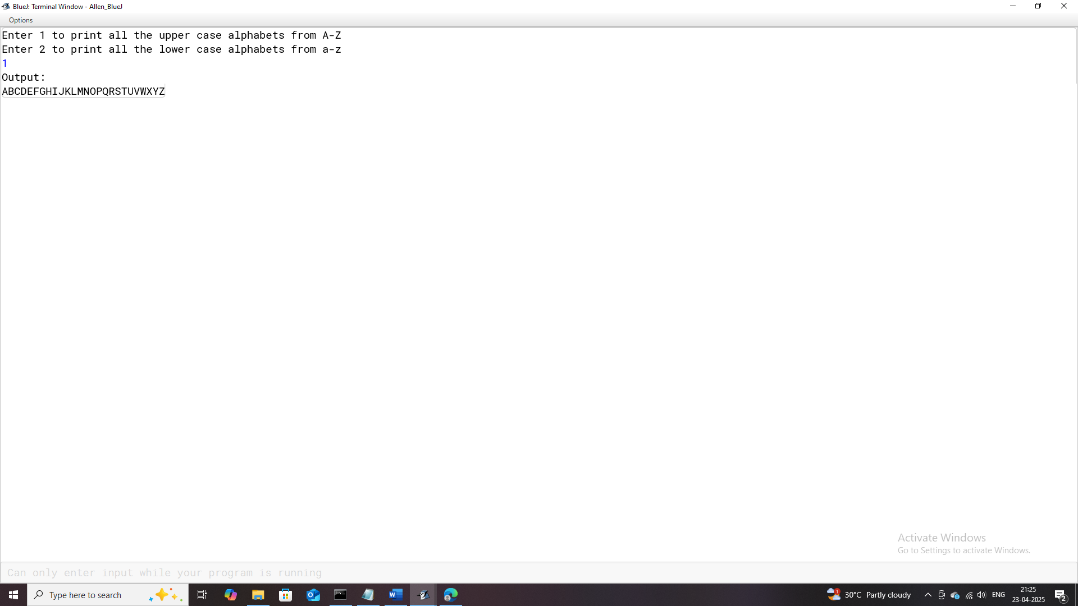

# **Program-26**

## **Program Name:** Ushwa_Number

### **Problem Statement:** Develop a menu-driven Java program that prints alphabets based on user selection:

* Print all uppercase alphabets from A to Z.
* Print all lowercase alphabets from a to z.

### **Java Code:**

import java.util.Scanner;

/**

* This program checks and displays if the entered 4 digit number is an Ushwa Number

*

* @author (Allen Thomas.M)

* @author email (allenthomasmuttikal@gmail.com)

* @author git(https://github.com/allenthomasmuttikal/Java_Project)

* @version (v1.0)

*/

public class Ushwa_Number

{

public static void main(String args[])

{

Scanner ob = new Scanner(System.in);

System.out.println("Enter a 4 digit number");

int num = ob.nextInt();

int number = num;

int sum = 0;

while(num != 0)

{

sum += num % 10;

num /= 10;

}

int summation = number % 10 + number / 1000;

System.out.println("Output:");

if(2 * summation == sum)

{

System.out.println(number+" is an Ushwa Number");

}

else

System.out.println(number+" is not an Ushwa Number");

}

}

### **Variables Used:**

| **Variable Name** | **Variable Datatype** | **Variable Description** |
| --- | --- | --- |
| **ob** | Scanner | Object used to read user input from the console. |
| **num** | int | Stores the 4-digit number entered by the user. |
| **number** | int | Temporarily holds the original value of num for further calculations and output. |
| **sum** | int | Stores the sum of all the digits in the 4-digit number num. |
| **summation** | int | Stores the sum of the first and last digits of the number number. |

### **Output:**

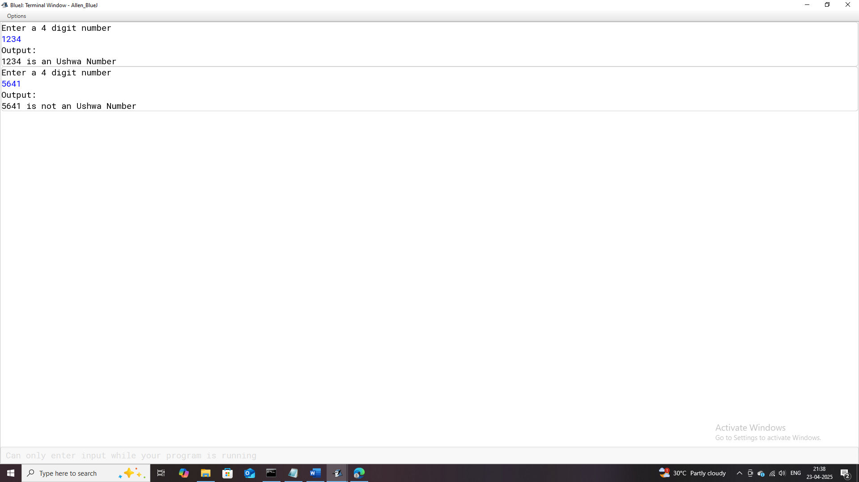

# **Program-27**

## **Program Name:** Days_Months

### **Problem Statement:** Design a Java program to determine the number of days in a given month of a specified year. Using Fall Through condition.

### **Java Code:**

import java.util.Scanner;

/**

* This program is to display the number of days in a month depending on the user's input.

* It does it through the Fall Through Condition.

*

* NOTE: Fall through condition : This condition occurs in the switch control statement

* when there is no break keyword mention for the particular case in the switch statement

* and cause execution of the cases till no break statement occurs or exit from the switch

* statement. This condition has its own advantage and disadvantage and it totally depends

* upon the type of operation we want in our program.

*

* @author (Allen Thomas.M)

* @author email (allenthomasmuttikal@gmail.com)

* @author git(https://github.com/allenthomasmuttikal/Java_Project)

* @version (v1.0)

*/

public class Days_Months

{

public static void main(String args[])

{

Scanner ob = new Scanner(System.in);

System.out.println("Enter any months number(1-12)");

int month = ob.nextInt();

System.out.println("Enter the year");

int year = ob.nextInt();

switch(month)

{

case 1:

case 3:

case 5:

case 7:

case 8:

case 10:

case 12:System.out.println("There are 31 days in this month");

break;

case 4:

case 6:

case 9:

case 11:System.out.println("There are 30 days in this month");

break;

case 2: if(year % 400 == 0 && year % 100 == 0)

System.out.println("There are 29 days in this month");

else if(year % 4 == 0 && year % 100 != 0)

System.out.println("There are 29 days in this month");

else

System.out.println("There are 28 days in this month");

break;

default:System.out.println("Invalid Input");

}

}

}

### **Variables Used:**

| **Variable Name** | **Variable Datatype** | **Variable Description** |
| --- | --- | --- |
| **ob** | Scanner | Object used to read user input from the console. |
| **month** | int | Stores the month number input by the user (1–12). |
| **year** | int | Stores the year input by the user to check for leap year conditions. |

### **Output:**

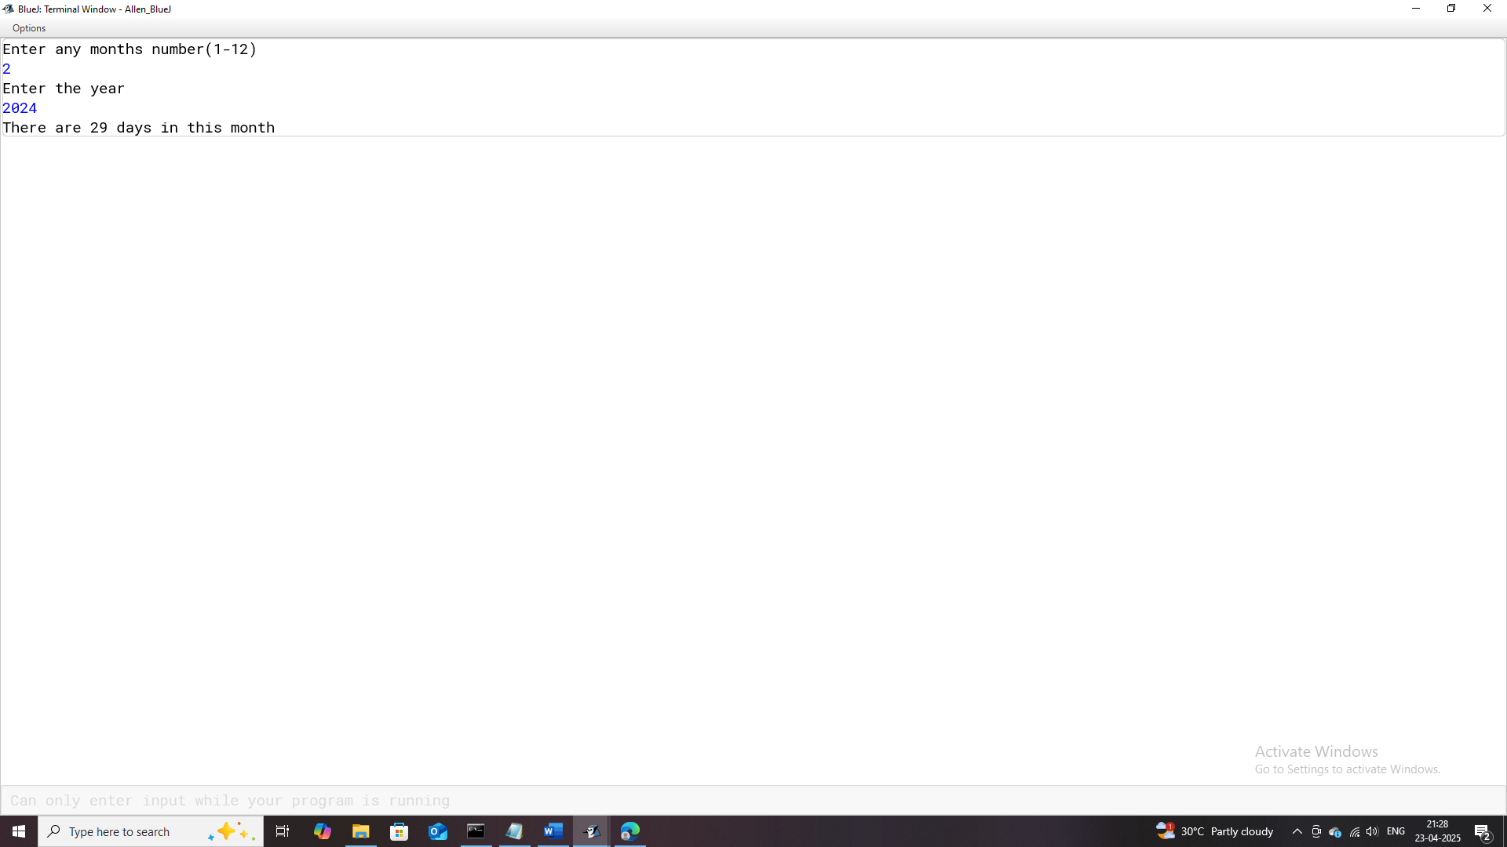

# **Program-28**

## **Program Name:** Series1

### **Problem Statement:** Create a menu-driven Java program to display or compute values for various mathematical series based on user selection.

### **Java Code:**

import java.util.Scanner;

/**

* This program displays a series or the sum of a series depending on the user's choice,using for loops.

*

* @author (Allen Thomas.M)

* @author email (allenthomasmuttikal@gmail.com)

* @author git(https://github.com/allenthomasmuttikal/Java_Project)

* @version (v1.0)

*/

public class Series1

{

public static void main(String args[])

{

Scanner ob = new Scanner(System.in);

System.out.println("Enter 1 to display series 1");

System.out.println("Enter 2 to print the sum of series 2");

System.out.println("Enter 3 to print the sum of series 3");

System.out.println("Enter 4 to print the sum of series 4");

System.out.println("Enter 5 to display series 5");

System.out.println("Enter 6 to display series 6");

int choice = ob.nextInt();

switch(choice)

{

case 1: System.out.println("Enter a limit");

int limit = ob.nextInt(); int s = 0;

System.out.println("Output:");

System.out.println("The series is : ");

for(int i = 0;i < limit;i++)

{

s += (int)Math.pow(10,i);

System.out.print(s+" ");

}

break;

case 2: System.out.println("Enter a value for variable 'a' ");

int a = ob.nextInt();int sum = 0;

for(int j = 1;j <= a;j++)

{

sum += (int)Math.pow(a,j);

}

System.out.println("Output:");

System.out.println("The sum of the series is : "+sum);

break;

case 3: System.out.println("Enter a value for variable 'a' ");

int c = ob.nextInt();double total=0.0d;

for(int l = 1;l <= 20;l++)

{

total += (c * l);

}

System.out.println("Output:");

System.out.println("The sum of the series is : "+total);

break;

case 4: int tally = 0;

for(int m = 1;m <= 19;m++)

{

tally += (m * (m + 1) );

}

System.out.println("Output:");

System.out.println("The sum of the series is : "+tally);

break;

case 5: System.out.println("Enter a limit");

int e = ob.nextInt();

System.out.println("Output:");

System.out.println("The series is : ");

for(int o = 1;o <= e;o++)

{

System.out.print((int)Math.pow(o,3) - 1+",");

}

break;

case 6: System.out.println("Enter a limit");

double f = ob.nextDouble();

System.out.println("Output:");

System.out.println("The series is : ");

for(double p = 1.50;p <= f;p += 1.50)

{

System.out.print(p+",");

}

break;

default:System.out.println("Invalid Input");

}

}

}

### **Variables Used:**

| **Variable Name** | **Variable Datatype** | **Variable Description** |
| --- | --- | --- |
| **ob** | Scanner | Object used to read user input from the console. |
| **choice** | int | Stores the user's choice for one of six series-related tasks. |
| **limit** | int | Stores the upper limit for generating series 1. |
| **s** | int | Accumulates the sum of powers of 10 for series 1. |
| **i** | int | Loop counter for iterating through powers in series 1. |
| **a** | int | Stores the input value for variable a in series 2. |
| **sum** | int | Stores the sum of powers of a for series 2. |
| **j** | int | Loop counter for calculating the sum in series 2. |
| **c** | int | Stores the input value for variable a in series 3. |
| **total** | double | Stores the calculated sum of the series in series 3. |
| **l** | int | Loop counter for calculating the sum in series 3. |
| **tally** | int | Stores the calculated sum of products in series 4. |
| **m** | int | Loop counter for calculating products in series 4. |
| **e** | int | Stores the upper limit for generating series 5. |
| **o** | int | Loop counter for generating series 5. |
| **f** | double | Stores the upper limit for generating series 6. |
| **p** | double | Loop counter for generating values in steps of 1.50 for series 6. |

### **Output:**

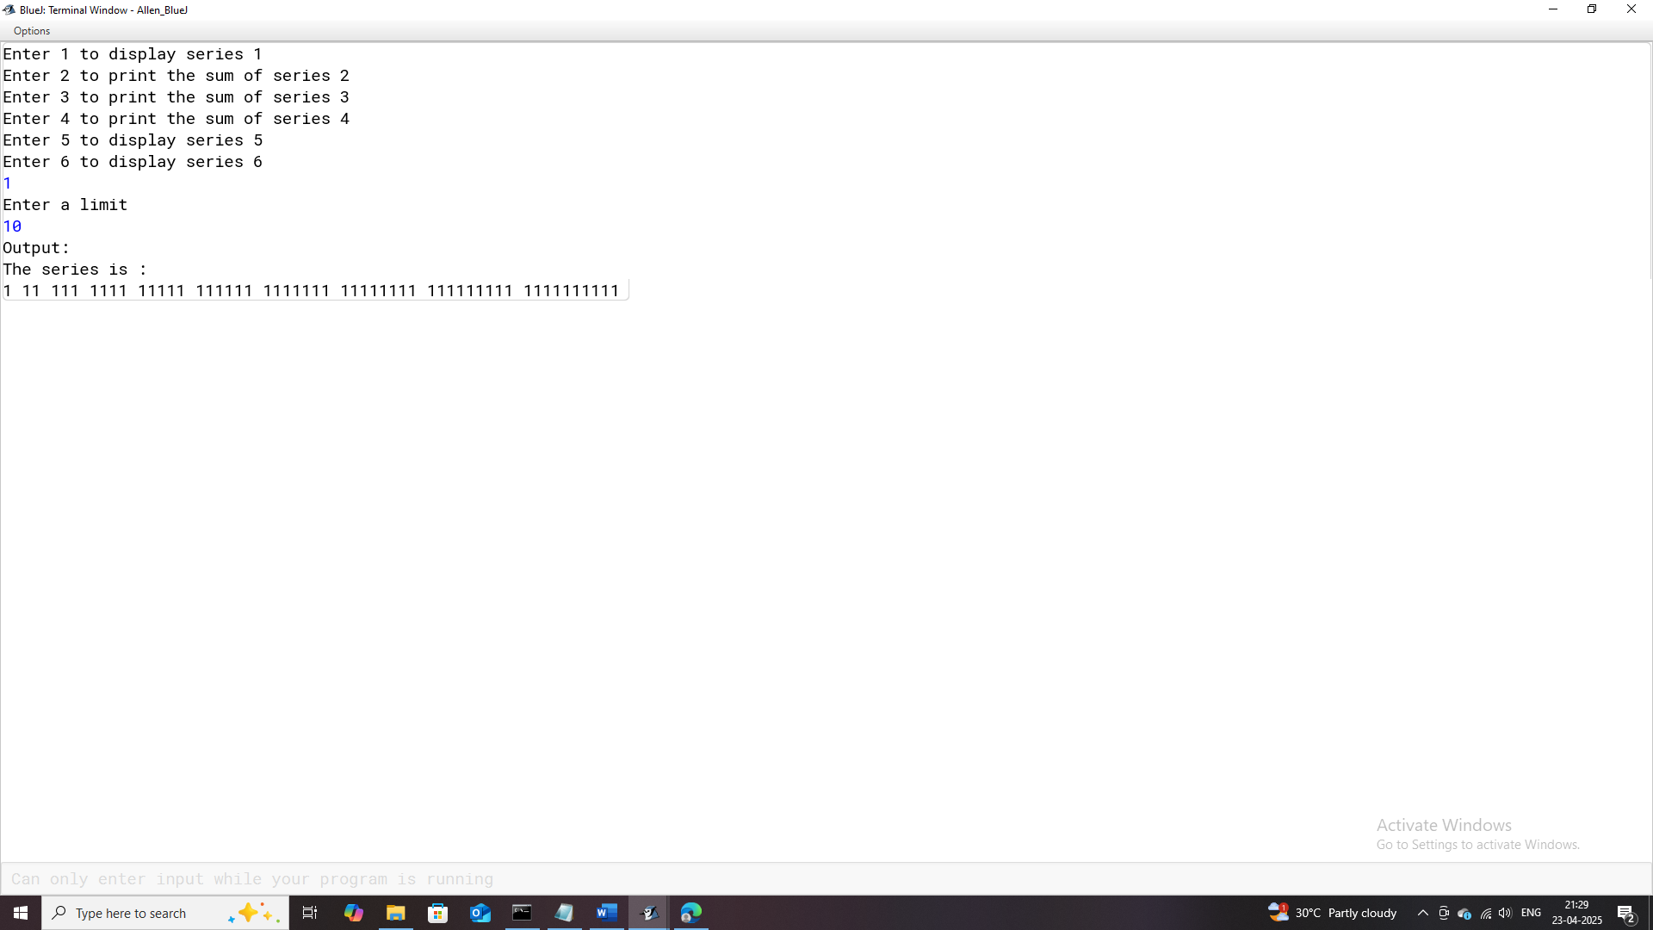

# **Program-29**

## **Program Name:** Magic_Number

### **Problem Statement:** Develop a Java program to determine whether a given number is a "Magic Number." A number is considered a Magic Number if the repeated sum of its digits reduces to a single digit, and that single digit is 1.

### **Java Code:**

import java.util.Scanner;

/**

* The program calls an entered number as a magic number if the repeated sum of its digits equals to 1

* Example: 253 -> 2 + 5 + 3 = 10 -> 1 + 0 = 1 (Hence 253 is a Magic Number)

* Example: 254 -> 2 + 5 + 4 = 11 -> 1 + 1 = 2 (254 is not a Magic Number since repeated sum of its digits not 1)

*

* @author (Allen Thomas.M)

* @author email (allenthomasmuttikal@gmail.com)

* @author git(https://github.com/allenthomasmuttikal/Java_Project)

* @version (v1.0)

*/

public class Magic_Number

{

public static void main(String args[])

{

Scanner ob = new Scanner(System.in);

System.out.println("Enter a number");

int num = ob.nextInt();

int n = num; int a = 0;

while(num > 9)

{

int sum = 0;

while(num != 0)

{

a = num % 10;

sum += a;

num /= 10;

}

num = sum;

}

System.out.println("Output:");

System.out.println("The repeated sum of digits is : "+num);

if(num == 1)

System.out.println(n+" is a Magic Number");

else

System.out.println(n+" is not a Magic Number");

}

}

### **Variables Used:**

| **Variable Name** | **Variable Datatype** | **Variable Description** |
| --- | --- | --- |
| **ob** | Scanner | Object used to read user input from the console. |
| **num** | int | Stores the number entered by the user for magic number evaluation. |
| **n** | int | Stores the original value of the input number num for output purposes. |
| **a** | int | Stores the remainder during digit extraction from num. |
| **sum** | int | Stores the intermediate sum of the digits of num during calculations. |

### **Output:**

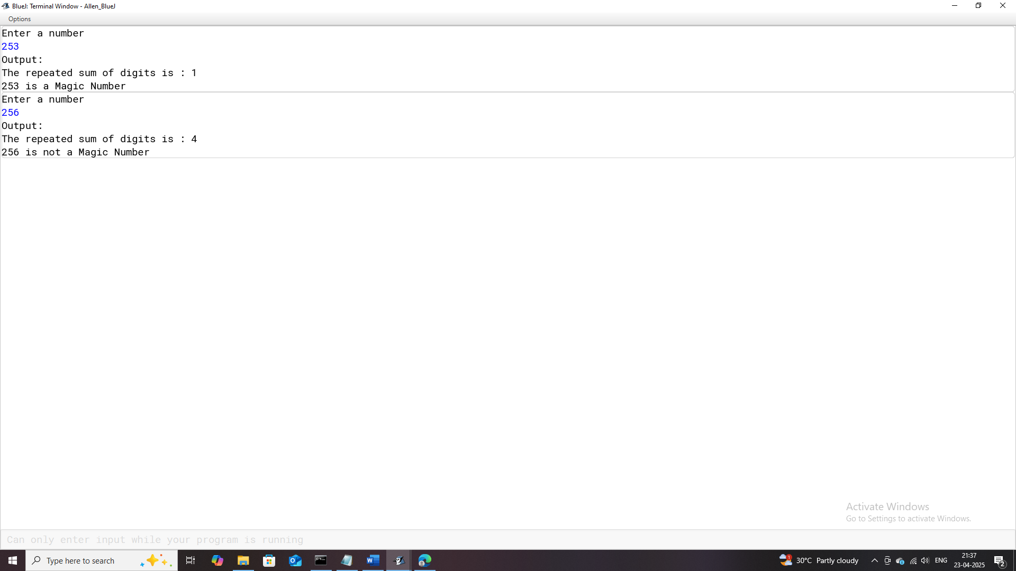

# **Program-30**

## **Program Name:** Fibonacci

### **Problem Statement:** Develop a Java program to generate and display the Fibonacci sequence up to a specified limit.

### **Java Code:**

import java.util.Scanner;

public class Fibonacci

{

public static void main(String args[])

{

Scanner ob=new Scanner(System.in);

System.out.println("Enter the limit");

int lim=ob.nextInt();

int a=0,b=1;

System.out.print(a+","+b);

for(int c=3;c<=lim;c++)

{

int d=a+b;

System.out.print(","+d);

a=b;

b=d;

}

}

}

### **Variables Used:**

| **Variable Name** | **Variable Datatype** | **Variable Description** |
| --- | --- | --- |
| **ob** | Scanner | Object used to read user input from the console. |
| **lim** | int | Stores the upper limit for generating the Fibonacci series. |
| **a** | int | Stores the first number in the Fibonacci sequence (initially set to 0). |
| **b** | int | Stores the second number in the Fibonacci sequence (initially set to 1). |
| **c** | int | Loop counter for generating subsequent numbers in the Fibonacci sequence. |
| **d** | int | Temporarily stores the sum of the previous two numbers in the Fibonacci sequence. |

### **Output:**

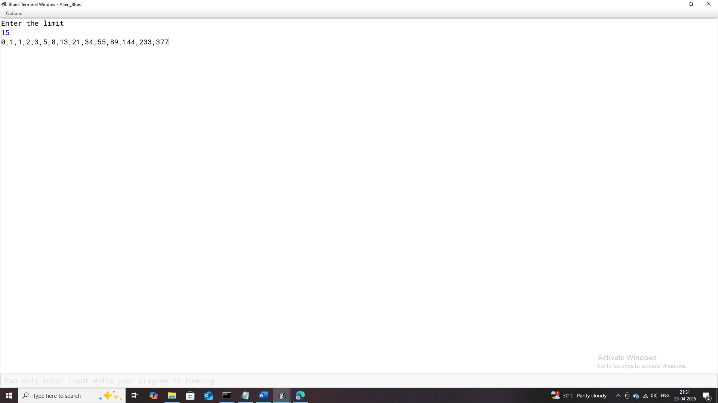

# **Program-31**

## **Program Name:** Tribonacci

### **Problem Statement:** Create a Java program that generates and displays the Tribonacci sequence up to a specified limit.

### **Java Code:**

import java.util.Scanner;

/**

* This program displays the tribonacci series till a given limit.

*

* @author (Allen Thomas.M)

* @author email (allenthomasmuttikal@gmail.com)

* @author git(https://github.com/allenthomasmuttikal/Java_Project)

* @version (v1.0)

*/

public class Tribonacci

{

public static void main(String args[])

{

Scanner ob = new Scanner(System.in);

System.out.println("Enter the limit");

int lim = ob.nextInt();

int a = 0,b = 1; int sum = 1;

System.out.println("Output:");

System.out.print(a+","+b+","+sum);

for(int c = 4;c <= lim;c++)

{

int d = a + b + sum;

System.out.print(","+d);

a = b;

b = sum;

sum = d;

}

}

}

### **Variables Used:**

| **Variable Name** | **Variable Datatype** | **Variable Description** |
| --- | --- | --- |
| **ob** | Scanner | Object used to read user input from the console. |
| **lim** | int | Stores the upper limit for generating the Tribonacci series. |
| **a** | int | Stores the first number in the Tribonacci sequence (initially 0). |
| **b** | int | Stores the second number in the Tribonacci sequence (initially 1). |
| **sum** | int | Stores the third number in the Tribonacci sequence (initially 1). |
| **c** | int | Loop counter for generating subsequent numbers in the Tribonacci series. |
| **d** | int | Temporarily stores the sum of the previous three numbers in the Tribonacci sequence. |

### **Output:**

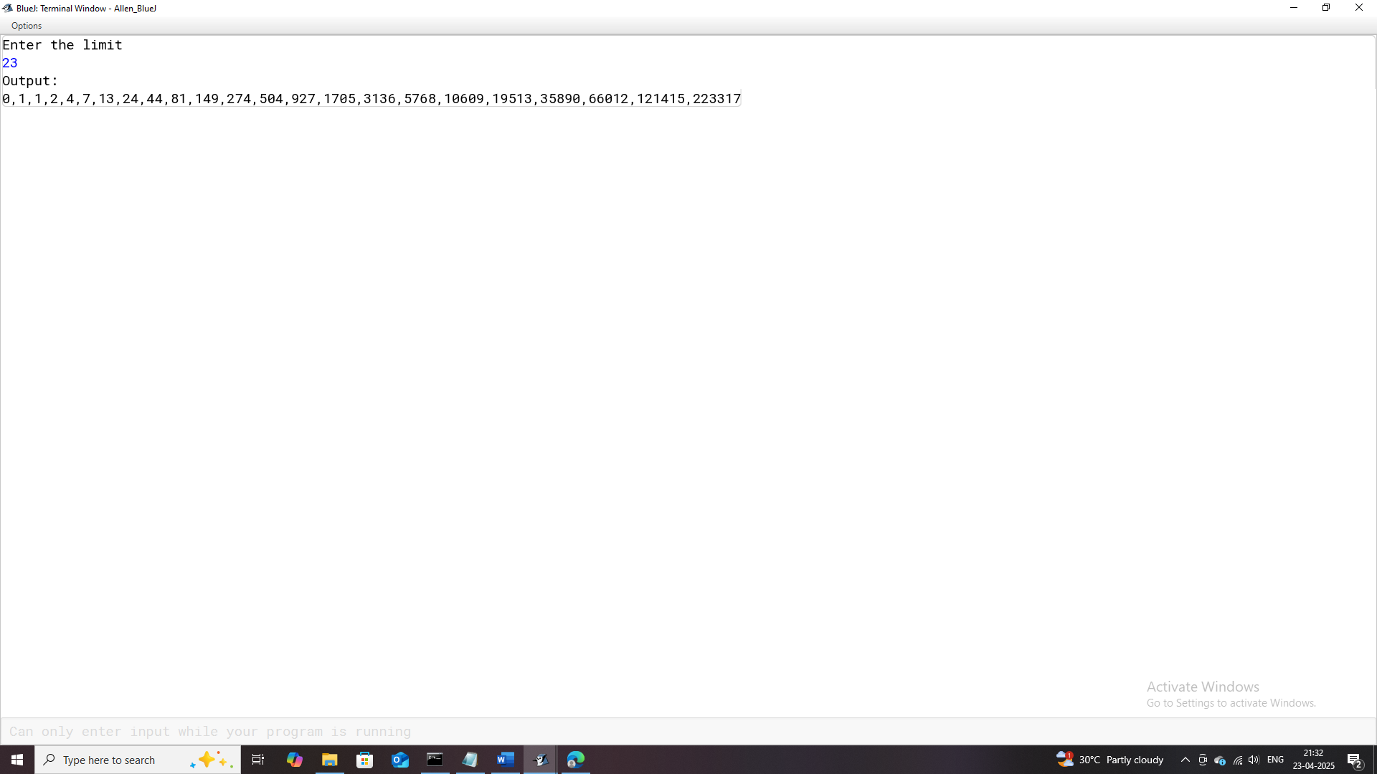

# **Program-32**

## **Program Name:** Sunny_Number

### **Problem Statement:** Develop a Java program to determine whether a given number is a "Sunny Number." A number is considered a Sunny Number if the square root of the number that follows it (n + 1) is a perfect square.

### **Java Code:**

import java.util.Scanner;

/**

* This program checks and displays if the entered number is a Sunny Number.

*

* @author (Allen Thomas.M)

* @author email (allenthomasmuttikal@gmail.com)

* @author git(https://github.com/allenthomasmuttikal/Java_Project)

* @version (v1.0)

*/

public class Sunny_Number

{

public static void main(String args[])

{

Scanner ob = new Scanner(System.in);

System.out.println("Enter the number");

int n = ob.nextInt();

int next_N = n + 1;

System.out.println("Output:");

if(Math.sqrt(n + 1) % 1 == 0)

System.out.println(n+" is a Sunny Number");

else

System.out.println(n+" is not a Sunny Number");

}

}

### **Variables Used:**

| **Variable Name** | **Variable Datatype** | **Variable Description** |
| --- | --- | --- |
| **ob** | Scanner | Represents the Scanner object for input. |
| **n** | int | Holds the integer input from the user. |
| **next_N** | int | Stores the next number after n. |

### **Output:**

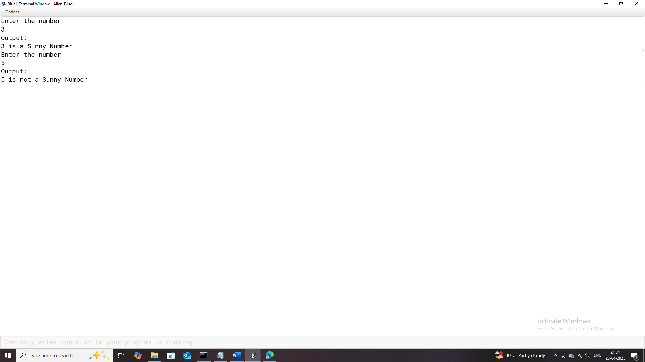

# **Program-33**

## **Program Name:** series

### **Problem Statement:** Develop a menu-driven Java program that generates and displays various patterns based on user selection.

### **Java Code:**

import java.util.Scanner;

/**

* This program displays certain patterns based on the user's choice.

*

* @author (Allen Thomas.M)

* @author email (allenthomasmuttikal@gmail.com)

* @author git(https://github.com/allenthomasmuttikal/Java_Project)

* @version (v1.0)

*/

public class series

{

public static void main(String args[])

{

Scanner ob = new Scanner(System.in);

System.out.println("Enter numbers from 1-10 to display respective patterns");

int choice = ob.nextInt();

switch(choice)

{

case 1:System.out.println("Output:");

for(int n = 1;n <= 5;n++)

{

for(int j = 1;j <= n;j++)

System.out.print(n);

System.out.println("");

}

break;

case 2:System.out.println("Output:");

for(int a = 6;a >= 1;a--)

{

for(int b = 1;b <= a;b++)

System.out.print(a);

System.out.println("");

}

break;

case 3: System.out.println("Output:");

for(int c = 9;c >= 1;c -= 2 )

{

for(int d = 5;d >= 1;d--)

System.out.print(c);

System.out.println("");

}

break;

case 4: System.out.println("Output:");

for(int e = 9;e >= 1;e -= 2)

{

for(int f = e;f <= 9;f += 2)

System.out.print(f);

System.out.println("");

}

break;

case 5: System.out.println("Output:");

for(int g = 9;g >= 1;g -= 2)

{

for(int h = 9;h >= g;h -= 2)

System.out.print(h);

System.out.println("");

}

break;

case 6: System.out.println("Output:");

for(int i =9;i >= 1;i -= 2)

{

for(int k = i;k >= 1;k -= 2)

System.out.print(k);

System.out.println("");

}

break;

case 7:System.out.println("Output:");

for(int o = 5;o >= 1;o--)

{

for(int p = o;p >= 1;p--)

System.out.print(p);

System.out.println("");

}

break;

case 8: System.out.println("Output:");

for(int q = 1;q <= 9;q += 2)

{

for(int r = 9;r >= q;r -= 2)

{

System.out.print(r);

}

System.out.println("");

}

break;

case 9:int count = 1;

System.out.println("Output:");

for(int t = 1;t <= 10;t++)

{

for(int s = 1;s <= t;s++)

{

System.out.print(count+" ");

count++;

}

System.out.println("");

if(count > 10)

break;

}

break;

case 10:System.out.println("Output:");

for(int l = 1;l <= 5;l++)

{

for(int m = 1;m <= l;m++)

{

if(m % 2 == 0)

System.out.print("#");

else

System.out.print("*");

}

System.out.println("");

}

break;

default:System.out.println("Invalid Input");

}

}

}

### **Variables Used:**

| **Variable Name** | **Variable Datatype** | **Variable Description** |
| --- | --- | --- |
| **ob** | Scanner | Represents the Scanner object used for taking input from the user. |
| **choice** | int | Stores the user's choice (1-10) to display respective patterns. |
| **n** | int | Loop variable used for iterating and generating patterns. |
| **j** | int | Inner loop variable used for generating repeated values in patterns (Case 1). |
| **a** | int | Loop variable for iterating patterns in reverse order (Case 2). |
| **b** | int | Inner loop variable for pattern generation in reverse order (Case 2). |
| **c** | int | Loop variable for decrementing pattern values (Case 3). |
| **D** | int | Inner loop variable used for repetitive pattern generation (Case 3). |
| **e** | int | Loop variable used for incrementing pattern values (Case 4). |
| **f** | int | Inner loop variable used for generating ascending values (Case 4). |
| **g** | int | Loop variable for generating descending values in patterns (Case 5). |
| **h** | int | Inner loop variable used for generating values less than the loop variable (Case 5). |
| **i** | int | Loop variable used for decrementing odd numbers in patterns (Case 6). |
| **k** | int | Inner loop variable for decrementing values in patterns (Case 6). |
| **o** | int | Loop variable used for generating reverse number sequences (Case 7). |
| **p** | int | Inner loop variable used for printing reverse sequences (Case 7). |
| **q** | int | Loop variable for incrementing odd numbers (Case 8). |
| **r** | int | Inner loop variable for decrementing values in patterns (Case 8). |
| **count** | int | Counter used for printing sequential numbers (Case 9). |
| **t** | int | Loop variable used for iterating rows in Case 9. |
| **s** | int | Inner loop variable for generating sequential numbers (Case 9). |
| **l** | int | Loop variable used for iterating rows with symbol patterns (Case 10). |
| **m** | int | Inner loop variable for alternating between symbols (Case 10). |

### Output:

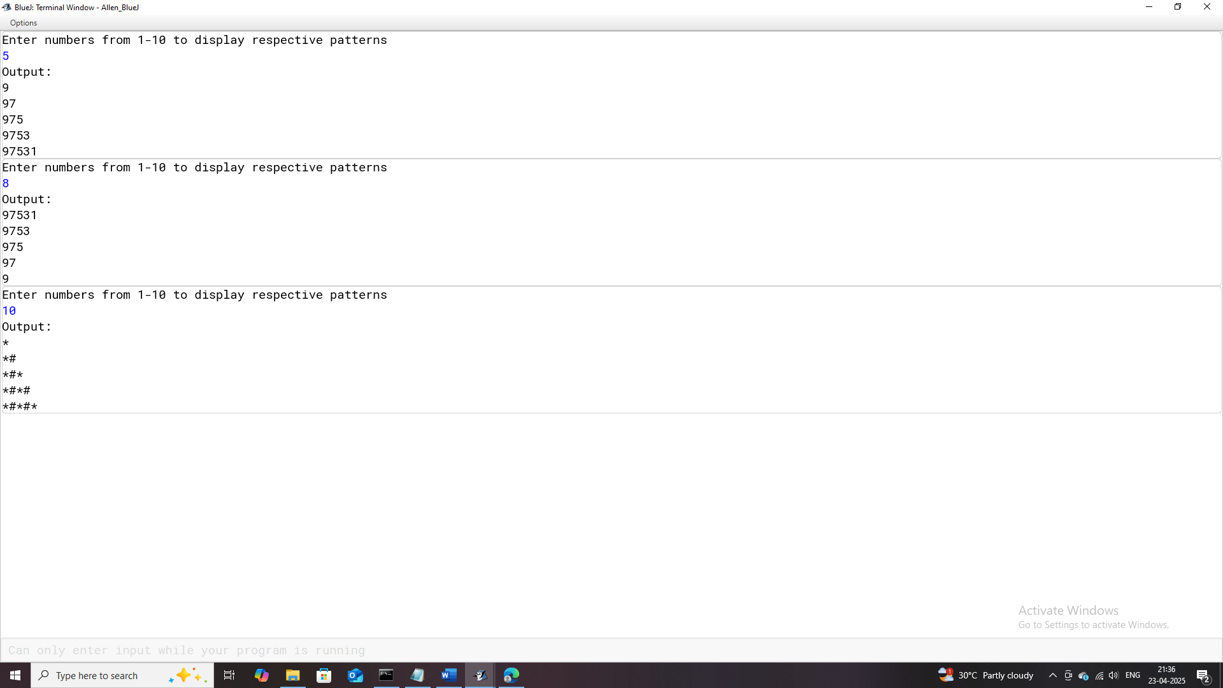

# **Project Acknowledgement**

I am deeply grateful to everyone who has supported and guided me throughout the completion of my Java Programming project. First and foremost, I would like to thank my computer science teacher, Mr Franklin Xavier, for providing me with the knowledge, inspiration, and encouragement to explore programming. Your patient guidance and valuable insights have been instrumental in shaping this project.

I would also like to express my sincere appreciation to my school, St. Joseph’s Boy’s High School, for fostering a learning environment that encourages creativity and innovation in technology. Special thanks to my family for their constant encouragement and understanding during the project development phase.

This project has been a wonderful opportunity to strengthen my problem-solving skills and deepen my understanding of Java programming concepts like conditional statements, loops, and the Scanner class.

Thank you all for being a part of this journey!

Sincerely,

Allen Thomas M

Grade 10 ‘C’